Nowhere Man Beatles key D

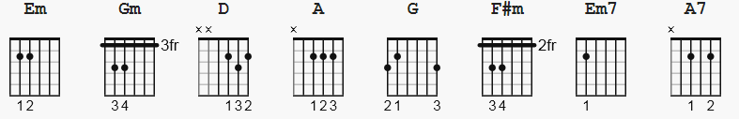

Capo II 121 bpm strum: old faithful D Du uDu
Gm = 310003
[Intro]:

D A
He's a real nowhere man
G D
Sitting in his nowhere land
Em Gm D
Making all his nowhere plans for nobody

D A
Doesn't have a point of view
G D
Knows not where he's going to
Em Gm D
Isn't he a bit like you and me?

F#m G
Nowhere man, please listen
F#m G
You don't know what you're missing
F#m Em7 A7
Nowhere man, the world is at your command

Solo/Instrumental
same chords as verse

(verse 2)

D A
He's as blind as he can be
G D
Just sees what he wants to see
Em Gm D
Nowhere man can you see me at all

F#m G
Nowhere man, don't worry
F#m G
Take your time, don't hurry
F#m Em7 A7
Leave it all till somebody else lends you a hand

D A
He's a real nowhere man,
G D
Sitting in his nowhere land,
Em Gm D
Making all his nowhere plans for nobody.
Em Gm D
Making all his nowhere plans for nobody.
Em Gm D
Making all his nowhere plans for nobody.

