Ohio Crosby, Stills, Nash and Young key Dm

NOTE: there is a different double downtuned D version, obviously different chords.

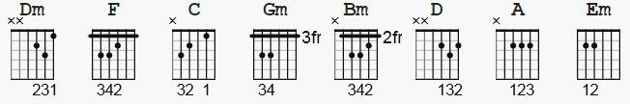

[Intro]

Dm F C 4x

Dm F C
Tin soldiers and Nixon's coming,
Dm F C
we're finally on our own.
Dm F C
This summer I hear the drumming,
Dm F C
four dead in Ohio.

Gm
Gotta get down to it,
C
soldiers are cutting us down.
Gm C
Should have been done long ago.
Gm
What if you knew her and,
C
found her dead on the ground?
Gm C
How can you run when you know?

Dm F C
Na, na, na, na, na, na, na,
Dm F C
Na, na, na, na, na, na, na,
Dm F C
Na, na, na, na, na, na, na,
Dm F C
Na, na, na, na, na, na, na,

Gm
Gotta get down to it,
C
soldiers are cutting us down.
Gm C
Should have been done long ago.
Gm
What if you knew her and,
C
found her dead on the ground?
Gm C
How can you run when you know?

Dm F C
Tin soldiers and Nixon's coming,
Dm F C
we're finally on our own.
Dm F C
This summer I hear the drumming,
Dm F C
four dead in Ohio.
Dm F C
Four dead in Ohio. 8x

* Alternate:

Capo III

Dm = Bm
F = D
C = A
Gm = Em

