One Horse Town Blackberry Smoke key Dm

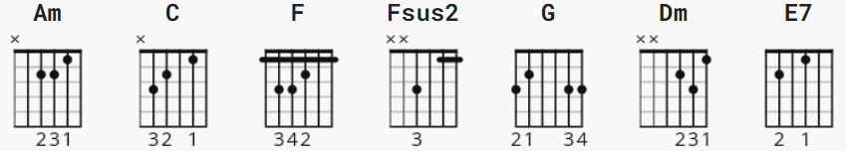

strum verse: D Du uDu ( old faithful)
chorus: DuDuDuDu ( chuggy sound, downbeats 2,4 )

[Intro]
Am C
e|-------------0-0----0-0----0-0------------0-0----0-0----0-0-|
B|-------------1-1----1-1----1-1------------1-1----1-1----1-1-|
G|-------------2-2----2-2----2-2------------0-0----0-0----0-0-|
D|-0-2-0-------2-2----2-2----2-2-0-2-0------2-2----2-2----2-2-| x2
A|-------3b-0-------------0------------2-3-------------3------|
E|-----------------0----------------------------3-------------|
b = slight bend

[Verse 1]
Dm F
In the tiny town where I come from
C G
You grew up doing what your daddy does
Dm F |C | F C |
And you don't ask questions, you do it just because
Dm F
You don't climb too high or dream too much
C G
With a whole lot of work and a little bit of luck
Dm F C C(1 strum)
You can wind up right back where your daddy was

[Chorus]
Am F
This little bitty town, it ain't nothing new
C | G | E7 |
We all stick around 'cause they all tell us to
Am C
Swallow your pride just to make your family proud
G F Fsus2 F
If I didn't think that it would shut the whole place down
F G Am
I'd ride my pony right out of this one horse town
C
Yeah this one horse town
[Verse 2]
Dm F
I'm an old married man at the age of 23
C G
Got two little boys on the baseball team
Dm F C F C
And that might be their only ticket out
Dm F
All they got is a worn out name
C G
And a daddy that could've gone all the way
Dm F C
But I hung my saddle up and I settled down

[Chorus]
Am F
This little bitty town, oh it ain't nothing new
C G E7
We all stick around 'cause they all tell us to
Am C
Swallow your pride just to make your family proud
G F Fsus2 F
If I didn't think that it would shut the whole place down
F G Am
I'd ride my pony right out of this one horse town
C
Yeah this one horse town

[Break]

Dm F C G
Dm F C

[Chorus]
Am F
This little bitty town, it ain't nothing new
C G E7
We all stick around 'cause they all tell us to
Am C
Swallow your pride just to keep your family proud
G F Fsus2 F
If I didn't think that it would shut the whole thing down
F G C
I'd saddle that one horse and ride it right out of this town

