Paint It Black Rolling Stones key Em

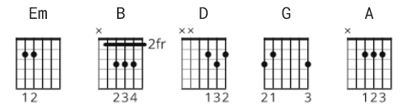

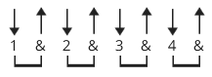 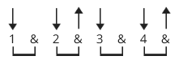 160 bpm
first 2 lines of verses last 2 lines of verses

[Intro]
Em B
Em

[Verse 1]

Em B
I see a red door and I want it painted black.
Em B
No colours anymore, I want them to turn black.
Em D G D Em
I see the girls walk by dressed in their summer clothes.
Em D G D A B
I have to turn my head until my darkness goes.

[Verse 2]

Em B
I see a line of cars and they're all painted black.
Em B
With flowers and my love both never to come back.
Em D G D Em
I see people turn their heads and quickly look away.
Em D G D A B
Like a newborn baby it just happens every day.

[Verse 3]

Em B
I look inside myself and see my heart is black.
Em B
I see my red door, I must have it painted black
Em D G D Em
Maybe then I'll fade away and not have to face the facts.
Em D G D A B
It's not easy facing up when your whole world is black.

[Verse 4]

Em B
No more will my green sea go turn a deeper blue.
Em B
I could not forsee this thing happening to you.
Em D G D Em
If I look hard enough into the setting sun
Em D G D A B
My love will laugh with me before the morning comes.

[Verse 5]

Em B
I see a red door and I want it painted black.
Em B
No colours anymore, I want them to turn black.
Em D G D Em
I see the girls walk by dressed in their summer clothes.
Em D G D A B
I have to turn my head until my darkness goes.

[Outro]

Em B
Em B
Em B
Em B

Em B
I wanna see it painted, painted black, black as night, black as coal
Em B
I wanna see the sun blotted out from the sky
Em B
I wanna see it painted, painted, painted, painted black, yeah

