Peaceful Easy Feeling Eagles key E (intermed)

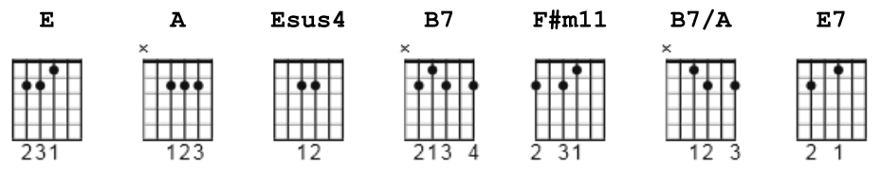

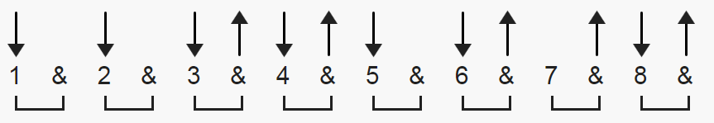 or D D DuDu + old faithful

OR- Just follow the numbered voicings listed below:

E = 022100 A = x02220
Esus4 = 022200 B7 = x21202
F#m11 = x44200 or 244200 B7/A = x01202
E7 = 020100

==========================================================

[Intro]

E Esus4 E F#m11
| / / / / | / / / / | / / / / | / / / / |

E7 A E7 A
| / / / / | / / / / | / / / / | / / / / |

[Verse 1]

E A E A
I like the way your sparkling ear -rings lay...
E A B7 B7/A
...against your skin, so brown,
E A E A
And I want to sleep with you in the desert to - night,
E A B7
With a billion stars all a - round!

[Chorus]
A E
'Cause I got a peaceful easy feeling,
A F#m11 B7
And I know you won't let me down-------,
E F#m11 A
'Cause I'm al------ready standing...
B7 E Esus4 E Esus4
...on the ground-------! | / / / / | / / / / |

[Verse 2]

E A E A
And I found out, a long time a - go,
E A B7 B7/A
What a woman can do to your soul,
E A E A
Awww, but she can't take you any--- way...
E A B7
...you don't already know how to go!

[Chorus]

A E
And I got a peaceful easy feeling,
A F#m11 B7
And I know you won't let me down-------,
E F#m11 A
'Cause I'm al------ready standing...
B7 E Esus4 E Esus4
...on the ground--------! | / / / / | / / / / |

[Instrumental]

E A E A
||: / / / / | / / / / | / / / / | / / / / |

E A B7
| / / / / | / / / / | / / / / | / / / / :||[x2]

A E
| / / / / | / / / / | / / / / | / / / / |

A F#m11 B7
| / / / / | / / / / | / / / / | / / / / |

E F#m11 A B7
| / / / / | / / / / | / / / / | / / / / |

[Verse 3]

E A E A
I get this feeling I may know you,
E A B7 B7/A
As a lover and a friend,
E A E A
But this voice keeps whispering in my other ear,
E A B7
Tells me, I may never see you a - gain!

[Chorus]

A E
'Cause I got a peaceful easy feeling,
A F#m11 B7
And I know you won't let me down-------,
E F#m11 A B7
'Cause I'm al--------ready standing...
E F#m11 A B7
I'm al--------ready standing...

[Coda]

E F#m11 A
Yes, I'm al--------ready standing...
B7 E F#m11 A B7
...on the ground-------! (Oo - hoo, hoo---!)
E F#m11 A B7 E F#m11
Woh - oh - oh-----! (Oo - hoo, hoo, hoo - hoo!)
A B7 E
(Oo - hoo, hoo - hoo, hoo!)

