Peaceful Easy Feeling Eagles key E (simple)

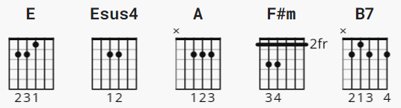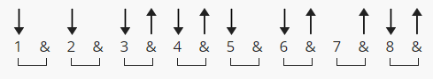

see NOTES page 3

verse and chorus D Du uDu 72 or 143 bpm; how U count !!

1 2&3&4&

[INTRO] (E | Esus4 = D DUDU DU | DU DU UDU )

| E | Esus4 | E | Esus4 | E | Esus4 | E | Esus4 |

[Verse 1] ( and verse 2 = 16 bars )

E A E A
I like the way your sparkling earrings lay
E A B7
Against your skin so brown
E A E A
And I want to sleep with you in the desert tonight
E A B7
With a billion stars all around

[Chorus] ( 12 bars )

A E
'Cause I got a peaceful, easy feeling
A F#m B7
And I know you won't let me down
E F#m A
'Cause I'm al-ready standing
B7 E
On the ground

[Interlude] ( ONLY after verse 1/chorus )

| E | Esus4 | E | Esus4 |

[Verse 2]

E A E A
And I found out a long time ago
E A B7
What a woman can do to your soul

E A E A
Aw, but she can't take you any way
E A B7
You don't already know how to go

[Chorus]

A E
And I got a peaceful, easy feeling
A F#m B7
And I know you won't let me down
E F#m A
'Cause I'm al-ready standing
B7 E
On the ground

[Instrumental]

| E | A | E | A | E | A | B7 | B7 |

| E | A | E | A | E | A | B7 | B7 |

| A | A | E | E | A | A | F#m | B7 |

| E | F#m | A | B7 |

[Verse 3]

E A E A
I get this feeling I may know you
E A B7
As a lover and a friend
E A E A
But this voice keeps whispering in my other ear
E A B7
Tells me I may never see you again

[Outro]

A E
'Cause I get a peaceful, easy feeling
A F#m B7
And I know you won't let me down
E F#m A B7
'Cause I'm al-ready standing
E F#m A B7
I'm al-ready standing
E F#m A
Yes, I'm al-ready standing

B7 E F#m A B7
On the ground (Ooooohh, oooooohhh, oooh)
E F#m A B7
Wooahh, Woooahh (Ooooohh, oooooohhh, oooh)
E F#m A B7 E
(Ooooohh, oooooohhh, oooh)

--------------------

Intro lick:
e ——————————————————————————————————————————————
B ——12-s-14(v)——14-s-12———10-s-12(v)——12-s-10———
G ——————————————————————————————————————————————
D ——————————————————————————————————————————————
A ——————————————————————————————————————————————
E ——————————————————————————————————————————————
OR:
e ——————————————————————————————————————————————
B ——12-b-14————14-r-12———10-b-12—————12-s-10————
G ——————————————————————————————————————————————
D ——————————————————————————————————————————————
A ——————————————————————————————————————————————
E ——————————————————————————————————————————————
s = slide
v = vibrato
b = bend
r = return

-------
CAPO 2:

E D
A G
B7 A7
F#m Em
Esus4 Dsus4

