Peter Cottontail Nelson/Rollins Gene Autry version

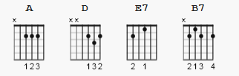

Capo 3 note: Nelson/Rollins sheet music shows no capo
and added chord E
[Verse]

A D
Here comes Peter Cottontail hoppin' down the bunny trail
E7 A
Hippity hoppity Easter's on its way
D
Bringing every girl and boy baskets full of Easter joy
E7 A
Things to make your Easter bright and gay
D
He's got jelly beans for Tommy
A
Colored eggs for sister Sue
D
There's an orchid for your Mommy
B7 E7
And an Easter bonnet too

[Chorus]

A D
Here comes Peter Cottontail hopping down the bunny trail
E7 A
Hippity hoppity happy Easter day

[Verse]

D
You'll wake up on Easter morning
A
And you'll know that he was there
D
When you find those chocolate bunnies
B7 E7
That he's hiding everywhere

[Chorus]

A D
Here comes Peter Cottontail hoppin' down the bunny trail
E7 A
Hippity hoppity happy Easter day

[Outro]

E7 A
Hippity hoppity happy Easter day

