Piano Man Billy Joel key C V2

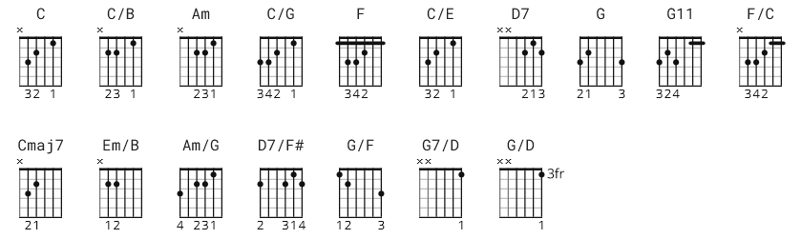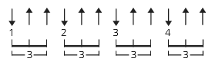
58 bpm
[Harmonica]

C C/B Am C/G F C/E D7 G
C C/B Am C/G F G11
C F/C Cmaj7 G11
C F/C Cmaj7 G11

[Verse]

C C/B Am C/G F C/E D7 G
It's nine o'clock on a Saturday, the regular crowd shuffles in
C C/B Am C/G F G11 C
There's an old man sitting next to me making love to his tonic and gin

[Harmonica]

C C/B Am C/G F G11
C F/C

[Verse]

C C/B Am C/G F C/E D7 G
He says son, can you play me a memory I'm not really sure how it goes
C Em/B Am C/G F G11 C
But it's sad and it's sweet and I knew it complete when I wore a younger man's clothes

[Bridge]

Am Am/G D7/F# F Am Am/G D7/F# D7 G G/F
Da da da de de Da dada dede da da da

[Chorus]

C/E G7/D C Em/B Am C/G F C/E D7 G
Sing us a song you're the piano man Sing us a song tonight
C Em/B Am C/G F G11 C
Well, we're all in the mood for a melody and you've got us feeling alright

[Harmonica]

C Em/B Am C/G F G11
C F/C Cmaj7 G11
C F/C Cmaj7 G11

[Verse]

C Em/B Am C/G F C/E D7 G
Now John at the bar is a friend of mine, he gets me my drinks for free
C Em/B Am C/G F G11 C
And he's quick with a joke or to light up your smoke but there's some place that he'd rather be

F/C C Em/B Am C/G F C/E D7 G
He says Bill I believe this is killing me as the smile ran away from his face
C Em/B Am C/G F G11 C
Well, I'm sure that I could be a movie star if I could get out of this place

[Bridge]

Am Am/G D7/F# F Am Am/G D7/F# D7 G G/F G
Da da da de de Da dada dede da da da

[Verse]

C Em/B Am C/G F C/E D7 G
Now Paul is a real estate novelist who never had time for a wife
C Em/B Am C/G F G11 C
And he's talking with Davy who's still in the navy and probably will be for life

[Harmonica]

C Em/B Am C/G F G11
C F/C

[Verse]

C Em/B Am C/G F C/E D7 G
And the waitress is practising politics as the businessmen slowly get stoned
C Em/B Am C/G F G11 C
Yes, they're sharing a drink they call loneliness but it's better than drinking alone

[Instrumental]

Am Am/G D7/F# F
Am Am/G D7/F# F
Am Am/G D7/F# D7
G G/F C/E G/D

[Chorus]

C Em/B Am C/G F C/E D7 G
Sing us a song you're the piano man Sing us a song tonight
C Em/B Am C/G F G11 C
Well, we're all in the mood for a melody and you've got us feeling alright

[Harmonica]

C C/B Am C/G F G11
C F/C Cmaj7 G11
C F/C Cmaj7 G11

[Verse]

C C/B Am C/G F C/E D7
It's a pretty good crowd for a Saturday and the manager gives me a smile
G C C/B Am C/G F G11 C
Cause he knows that it's me they've been coming to see, to forget about life for a while

C F/C Cmaj7 G11 C C/B Am C/G F C/E D7
And the piano sounds like a carnival and the microphone smells like a beer
C C/B Am C/G F G11 C
And they sit at the bar and put bread in my jar and say man what are you doing here ?

[Bridge]

Am Am/G D7/F# F Am Am/G D7/F# D7 G G/F C/E G/D
Da da da de de Da dada dede da da da
[Chorus]

C/E G7/D C C/B Am C/G F C/E D7 G
Sing us a song you're the piano man Sing us a song tonight
C C/B Am C/G F G11 C
Well, we're all in the mood for a melody and you've got us feeling alright

[Harmonica]

C C/B Am C/G F G11
C F/C Cmaj7 G11
C F/C Cmaj7 G/F C/E G/D C

