Piano Man Billy Joel key C

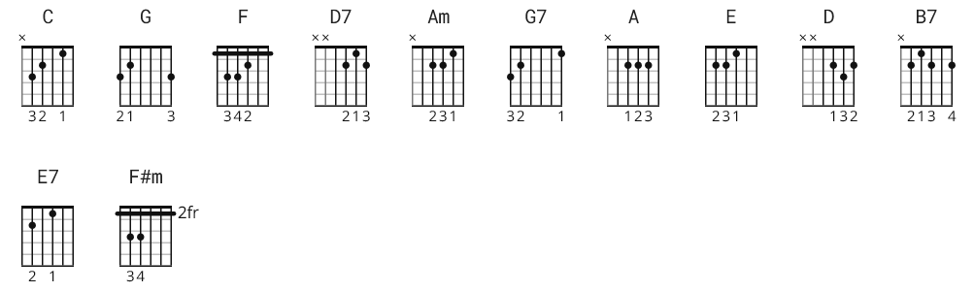

[Intro]

C G F C F C D7 G C G F C F G C G

[Verse 1]

C G F C
It's nine o'clock on a Saturday
F C D7 G
The regular crowd shuffles in
C G F C
There's an old man sitting next to me
F G C G
Making love to his tonic and gin

C G F C
He says, "Son, can you play me a memory
F C D7 G
I'm not really sure how it goes
C G F C
But it's sad and it's sweet and I knew it complete
F G C
When I wore a younger man's clothes."

[Interlude]

Am D7
la la la, di da da
Am D7 G F C G7
La la, di di da da dum

[Chorus]

C G F C
Sing us a song, you're the piano man
F C D7 G
Sing us a song tonight
C G F C
Well, we're all in the mood for a melody
F G C G
And you've got us all feeling alright

[Verse 2]

C G F C
Now John at the bar is a friend of mine
F C D7 G
He gets me my drinks for free
C G F C
And he's quick with a joke and he'll light up your smoke
F G C G
But there's some place that he'd rather be

C G F C
He says, "Bill, I believe this is killing me."
F C D7 G
As the smile ran away from his face
C G F C
"Well I'm sure that I could be a movie star
F G C
If I could get out of this place"

[Interlude]

Am D7
la la la, di da da
Am D7 G F C G7
La la, di di da da dum

[Verse 3]

C G F C
Now Paul is a real estate novelist
F C D7 G
Who never had time for a wife
C G F C
And he's talking with Davy, who's still in the Navy
F G C G
And probably will be for life

C G F C
And the waitress is practicing politics
F C D7 G
As the businessman slowly gets stoned
C G F C
Yes, they're sharing a drink they call loneliness
F G C G
But it's better than drinking alone
[Chorus]

C G F C
Sing us a song, you're the piano man
F C D7 G
Sing us a song tonight
C G F C
Well, we're all in the mood for a melody
F G C G
And you've got us all feeling alright

[Verse 4]

C G F C
It's a pretty good crowd for a Saturday
F C D7 G
And the manager gives me a smile
C G F C
'Cause he knows that it's me they've been coming to see
F G C G
To forget about life for a while

C G F C
And the piano, it sounds like a carnival
F C D7 G
And the microphone smells like a beer
C G F C
And they sit at the bar and put bread in my jar
F G C G
And say, "Man, what are you doing here?"

[Interlude]

Am D7
la la la, di da da
Am D7 G F C G7
La la, di di da da dum

[Chorus]

C G F C
Sing us a song, you're the piano man
F C D7 G
Sing us a song tonight
C G F C
Well, we're all in the mood for a melody
F G C
And you've got us all feeling alright

