Play Something We Know Adam Hood key A, finger G

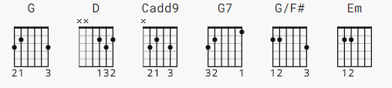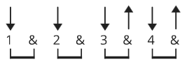

CAPO 2 some people prefer C rather than Cadd9

[Intro]
G D Cadd9 G
G D Cadd9 G

[Verse 1]

G D Cadd9 G
I saw you walk in here with that guitar in your hand
G D Cadd9 D
Thought I might ask you what you might be playing
G D Cadd9 G
Just one more question, well, I know you got to go
G D Cadd9 G
Me and my friends are drinking we're just wondering if you know

[Chorus 1]

G Cadd9 G
Any Lynyrd Skynyrd or American Pie
G D G G7
Willie and Waylon, Magic Carpet ride
G7 Cadd9 G G/F# Em
How bout' Marshall Tucker or David Allen C-o-o-o-o-o-e
Em Cadd9 D G
Play something we can sing to, play something we know

[Verse 2]

G D Cadd9 G
Well I know how it is dude, I use to have me a band
G D Cadd9 D
Til our drummer Ronnie, he got on down at the plant
G D Cadd9 G
Singer got a girlfriend, you know how that goes
G D Cadd9 G
So sing something we can sing to, play something we know
[Chorus 2]

G Cadd9 G
Do you know any Buffett, or any Pink Floyd
G D G G7
How bout some Dead, dude? How 'bout the Doors
G7 Cadd9 G G/F# Em
Do ya know any Beatles or any Rolling St..oh ones?
Em Cadd9 D G
Play something we can sing to play something we know

[Bridge]

Em D Cadd9 G
Man if you want me to I'll sing a song with you
Em Cadd9 D
I use to sing the high part
Em D Cadd9 G
My brother Donnie is sitting at the bar
Em Cadd9 D
He plays a mean guitar

[Verse 3]

G D Cadd9 G
What are you looking at man, you dont want me to play
G D Cadd9 D
Well you bout to get your ass whooped, you keep looking at me that way
G D Cadd9 G
Man I dont really mean it, there?s no need to call security
G D Cadd9 G
I was only hoping you would sing a song for me

[Chorus 3]

G Cadd9 G
Do you know Hank Jr. , or any Steve Earle
G D G G7
How bout the Joker, or Brown Eyed Girl,
G7 Cadd9 G G/F# Em
Sweet Home Alabama, or Curtis Loo..oo..owe
Em Cadd9 D G
Play something we can sing to, play something we know

-----
END

