Poison Ivy the Coasters key Ab ( chording G )

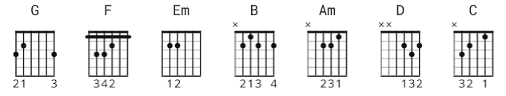 capo 1

[Intro]
| G | G F G | G | G F G |

[Verse 1]
G G F G
She comes on like a rose
G G F G
But everybody knows
G G F G
She'll get you in Dutch
G
You can look but you better not touch

[Chorus]
Em B
Poison Ivy, Poison Ivy
Em
Late at night while you're sleeping
Am Em D <-> Em,D 3 strums ea..
Poison Ivy comes a-creeping around

[Verse 2]
G G F G
She's pretty as a daisy
G G F G
But look out man, she's crazy
G G F G
She'll really do you in
G
If you let her get under your skin

[Chorus]
Em B
Poison Ivy, Poison Ivy
Em
Late at night while you're sleeping
Am Em D
Poison Ivy comes a-creeping around

[Bridge]
C
Measles make you mumpy and mumps will make you lumpy
G
And chicken pox will make you jump and twitch
C
A common cold will fool you and whooping cough can cool ya
D
But Poison Ivy, Lord, will make you itch

[Verse 3]
G G F G
You're gonna need an ocean
G G F G
Of calamine lotion
G G F G
You'll be scratching like a hound
G
The minute you start to mess around

[Chorus]
Em B
Poison Ivy, Poison Ivy
Em
Late at night while you're sleeping
Am Em D
Poison Ivy comes a-creeping around

[Bridge]
C
Measles make you mumpy and mumps will make you lumpy
G
And chicken pox will make you jump and twitch
C
A common cold will fool you and whooping cough can cool ya
D
But Poison Ivy, Lord, will make you itch

[Verse 4]
G G F G
You're gonna need an ocean
G G F G
Of calamine lotion
G G F G
You'll be scratching like a hound
G
The minute you start to mess around

[Chorus]
Em B
Poison Ivy, Poison Ivy
Em
Late at night while you're sleeping
Am Em D
Poison Ivy comes a-creeping around

[Outro]
G G F G
La la la la
G G F G
La la la la
G G F G
La la la la

(repeat and fade)

