(Oh) Pretty Woman - Orbison Roy

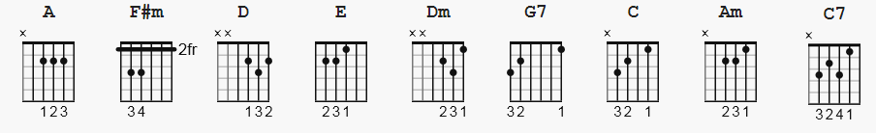

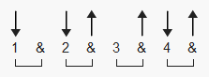 127 bpm

Riff 1:

v v v v v v
|-------------------------|
|-------------------------|
|-------------------------|
|---------0---------------|
|-------2-----------------|
|-0-0-4-------------------|

Riff 2:

v v v v
|-----------------|
|-----------------|
|-----------------|
|---------0-4-2-0-|
|-------2---------|
|-0-0-4-----------|

Intro:

drums alone (1 measure)
Riff 1 (acoustic guitar) 2X
Riff 2 (w/ electric and bass guitars) 4X
(more electrics enter on 3rd repeat)

Verse 1:
A F#m
Pretty woman walking down the street
A F#m
Pretty woman the kind I'd like to meet
D
Pretty woman
E
I don't be-lieve you, you're not the truth
E7
No one could look as good as you (Mercy!)

(Riff 2, 4X)Verse 2:
A F#m
Pretty woman won't you pardon me
A F#m
Pretty woman I couldn't help but see
D E
Pretty woman That you look lovely as can be
E7
Are you lonely just like me (Rrrrowrr...)

(Riff 2, 4X)

Bridge:

Dm G7
Pretty woman stop a while
C Am
Pretty woman talk a while
Dm G7 C
Pretty woman give your smile to me
Dm G7
Pretty woman, yeah yeah yeah
C Am
Pretty woman look my way
Dm G7 C A
Pretty woman say you'll stay with me
F#m Dm E
'Cause I need you I'll treat you right
A F#m Dm E
Come with me baby Be mine to-night

(Riff 2, 4X)

Verse 3 (incomplete):
A F#m
Pretty woman don't walk on by
A F#m
Pretty woman don't make me cry
D E E7
Pretty woman don't walk away, hey

Coda:

E E7
OK... if that's the way it must be, OK
E
I guess I'll go on home, it's late
E7
There'll be tomorrow night, but wait [ pause ]

(drums only)

What do I see ?

(Riff 1, 2X)
(Riff 2, 8X)

E E7 E E7 E E7
Is she walking back to me
E
Yes, she's walking back to me
E D A
Ohhhhhhh, ohhhhhhh, pretty woman

