Proud Mary CCR key D

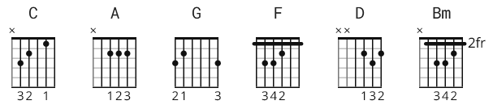

C A C A C A G F G \ D
D

D
Left a good job in the city

Workin' for the man ev'ry night and day

And I never lost one minute of sleepin'

Worryin' 'bout the way things might have been

A
Big wheel keep on turnin'
Bm
Proud Mary keep on burnin'
D
Rollin', rollin', rollin' on the river

D
Cleaned a lot of plates in Memphis

Pumped a lot of pane down in New Orleans

But I never saw the good side of the city

'Til I hitched a ride on a river boat queen

A
Big wheel keep on turnin'
Bm
Proud Mary keep on burnin'
D
Rollin', rollin', rollin' on the river

C A C A C A G F G \ D
D

D
If you come down to the river

Bet you gonna find some people who live

You don't have to worry 'cause you have [if you got] no money

People on the river are happy to give

A
Big wheel keep on turnin'
Bm
Proud Mary keep on burnin'
D
Rollin', rollin', rollin' on the river

D
Rollin', rollin', rollin' on the river 3x

