Ramblin Man The Allman Brothers Band

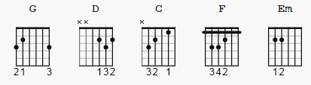 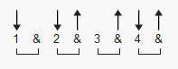 182 bpm

capo 1

[Intro]
|G |D |C |C G |

[Chorus]
G F C G
Lord I was born a ramblin' man
G C D
Tryin' to make a living and doing the best I can
C G Em C
When it's time for leaving I hope you'll understand
G D G
That I was born a ramblin' man

[Verse]
G C G
My father was a gambler down in Georgia
G C D
And he wound up on the wrong end of a gun
C G Em C
And I was born in the back seat of a Greyhound bus
G D G
Rolling down highway forty-one

[Chorus]
G F C G
Lord I was born a ramblin' man
G C D
Tryin' to make a living and doing the best I can
C G Em C
When it's time for leaving I hope you'll understand
G D G D
That I was born a ramblin' man

[Instrumental]
G D C G
G C G
G C D
C G Em C
G D G

[Verse]
G C G
I'm on my way to New Orleans this morning
G C D
Leavin' out of Nashville, Tennessee
C G Em C
They're always havin' a good time down on the Bayou, Lord
G D G
Them delta women think the world of me

[Chorus]
G F C G
Lord I was born a ramblin' man
G C D
Tryin' to make a living and doing the best I can
C G Em C
When it's time for leaving I hope you'll understand
G D G
That I was born a ramblin' man

[Chorus]
G F C G
Lord I was born a ramblin' man
G F C G
Lord I was born a ramblin' man
G F C G
Lord I was born a ramblin' man
G F C G
Lord I was born a ramblin' man
G F C G

[Ending]
G F C G

