Ramblin Man Allman Bros key G ( G# with capo )

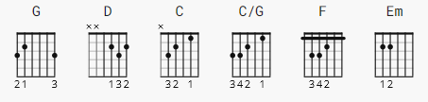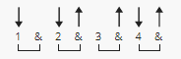

capo 1

[Intro]

G D C C/G

[Chorus]

G F G
Lord, I was born a ramblin' man
C D
Trying to make a living and doing the best I can
C G Em C
But when it's time for leavin', I hope you'll understand
G D G
That I was born a ramblin' man

[Verse 1]

G C G
My father was a gambler down in Georgia
C D
And he wound up on the wrong end of a gun
C G Em C
And I was born in the back seat of a Greyhound bus
G D G
Rolling down highway forty-one

[Chorus]

G F G
Lord, I was born a ramblin' man
C D
Trying to make a living and doing the best I can
C G Em C
But when it's time for leavin', I hope you'll understand
G D G
That I was born a ramblin' man

Play “Intro to Solo”; then “Solo” (rhythm plays intro & verse).

[Verse 2]

G C G
I'm on my way to New Orleans this morning
C D
Leaving out of Nashville, Tennessee
C G Em C
They're always having a good time down on the Bayou, Lord
G D G
Them delta women think the world of me.

[Chorus]

G F G
Lord, I was born a ramblin' man
C D
Trying to make a living and doing the best I can
C G Em C
But when it's time for leavin', I hope you'll understand
G D G
That I was born a ramblin' man

[Outro]

G F G
Lord, I was born a ramblin' man 4x

*Solo* G F G *(repeat n fade...)*

