Roadhouse Blues Doors

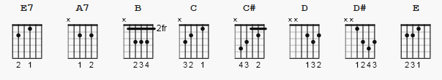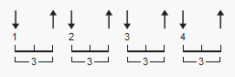
120 bpm

[Intro]

E7 X12

[Verse 1]

E7
Keep your eyes on the road, your hand upon the wheel.
Keep your eyes on the road, your hand upon the wheel.
Yeah, we're goin’ to the roadhouse,
Gonna have a real, a good time.

E7 X4
[Verse 2]

E7
Yeah, the back of the roadhouse they got some bungalows.
Yeah, in back of the roadhouse they got some bungalows.
And that's for the people who like to go down slow.

[Chorus]

A7
Let it roll, baby, roll.
Let it roll, baby, roll
Let it roll, baby, roll
B C B
Let it roll all night long.

[Guitar Solo}

E7 x18

(2nd time spoken: «Do it, Robby, do it»)

[Bridge]

E7
You gotta roll, roll, roll,
You gotta thrill my soul, all right.
Roll, roll, roll, rolla thrill my soul.
You gotta beep a gunk a chucha, honk konk konk.
You gotta each you puna,
Each ya bop a luba,
Each yall bump a kechonk,
Ease sa kunk, yeah, ride.

E7 X3

E7
Ashen lady, ashen lady,
Give up your vows, give up your vows.
Save our city, save our city, right now

[Verse 3]

E7
Well, I woke up this morning, I got myself a beer.
Well, I woke up this morning and I got myself a beer.
The future's uncertain and the end is always near.

[Chorus]

A7
Let it roll, baby, roll.
Let it roll, baby, roll.
Let it roll, baby, roll.
B C C# D D# E
Let it roll, yeah, all night long.

E9 = 020102 END

