Rockin' Around The Christmas Tree Brenda Lee key C

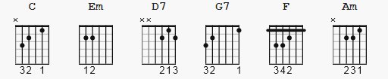

CAPO 1

[Intro]

C Em C D7

C G7
Rocking around the Christmas tree at the Christmas party hop
C
Mistletoe hung where you can see every couple tries to stop
G7
Rocking around the Christmas tree, let the Christmas spirit ring
C
Later we'll have some pumpkin pie and we'll do some caroling

F Em
You will get a sentimental feeling when you hear
Am D7 G7
Voices singing let's be jolly, deck the halls with boughs of holly
C G7
Rocking around the Christmas tree, have a happy holiday
C
Everyone dancing merrily in the new old-fashioned way

F Em
You will get a sentimental feeling when you hear
Am D7 G7
Voices singing let's be jolly, deck the halls with boughs of holly
C G7
Rocking around the Christmas tree, have a happy holiday
C
Everyone dancing merrily in the new old-fashioned way
C D7 D7 D7 G7 C
Everyone dancing merrily in the new old - fa - shioned way

NOTES: in one transposition from G to C, the "7" chords in This
become plain triad chords. ( here, G7 would become G, D7 -> D )

