Rockin' Around The Christmas Tree Brenda Lee key G

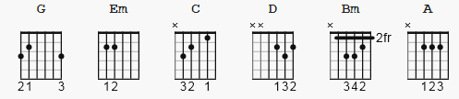

no capo

[Intro]

G Em C D

G D
Rocking around the Christmas tree at the Christmas party hop
D G
Mistletoe hung where you can see every couple tries to stop
G D
Rocking around the Christmas tree, let the Christmas spirit ring
D G
Later we'll have some pumpkin pie and we'll do some caroling

C Bm
You will get a sentimental feeling when you hear
Em A D
Voices singing let's be jolly, deck the halls with boughs of holly
G D
Rocking around the Christmas tree, have a happy holiday
D G
Everyone dancing merrily in the new old-fashioned way

C Bm
You will get a sentimental feeling when you hear
Em A D
Voices singing let's be jolly, deck the halls with boughs of holly
G D
Rocking around the Christmas tree, have a happy holiday
D G
Everyone dancing merrily in the new old-fashioned way
D D D D G C G
Everyone dancing merrily in the new old - fa - shioned way

