Rockin in the Free World Neil Young key G and E

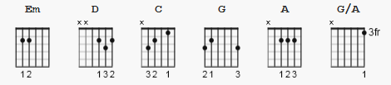 A9sus4= no fingers x000000

Tune down one whole step; key of Dm

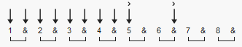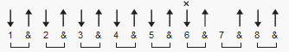
Intro/Instrumental/solo 132 bpm Verse

https://www.youtube.com/watch?v=DvxxdZpMFHg

strum chorus basic: D D DuDu
---------------------------

[Intro]

| Em | D C | x4

[Verse 1]

Em | D C | Em | D C |
Colours on the street, Red white and blue
Em D C Em D C
People shufflin' their feet, People sleepin' in their shoes
Em D C
But there's a warnin' sign on the road ahead
Em D C
There's a lot of people sayin' we'd be better off dead
Em D C
Don't feel like Satan but I am to them
Em D C
so I try to forget it anyway I can

[Chorus]

G D | C | C/B Em | G->
Keep on rockin' in the free world
G D C C/B Em
Keep on rockin' in the free world
G D C C/B Em
Keep on rockin' in the free world
G D C C/B Em
Keep on rockin' in the free world
[Interlude]

|A |A9sus4 A| 2x (can use G/A in place of A9sus4)
|Em | D C | 4x

[Verse 2]

Em D C Em D C
I see a woman in the night, with a baby in her hand
Em D C Em D C
Under an old street light, near a garbage can
Em D C
Now she puts the kid away and she's gone to get a hit
Em D C
She hates her life and what she's done to it
Em D C
That's one more kid that will never go to school
Em D C
Never get to fall in love never get to be cool

[Chorus]

G D C C/B Em
Keep on rockin' in the free world
G D C C/B Em
Keep on rockin' in the free world
G D C C/B Em
Keep on rockin' in the free world
G D C C/B Em
Keep on rockin' in the free world

[solo]

|A |A9sus4 A| 2x
|Em | D C | 8x

[Verse 3]
Em D C
We got a thousand points of light
Em D C
For the homeless man
Em D C |Em | D C |
We got a kinder gentler ma-chine gun hand
Em D C
We got de-partment stores and toilet paper
Em D C
Got styrofoam boxes for the ozone layer
Em D C
Got a man of the people says keep hope a-live
Em D C
Got fuel to burn got roads to drive
[Chorus]

G D C C/B Em
Keep on rockin' in the free world
G D C C/B Em
Keep on rockin' in the free world
G D C C/B Em
Keep on rockin' in the free world
G D C C/B Em
Keep on rockin' in the free world

[Outro]

|A |A9sus4 A| 2x
|Em | D C | fade out

