Run Away From It All Blackberry Smoke key G or C

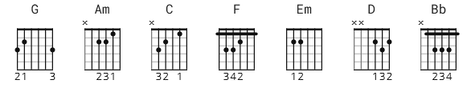
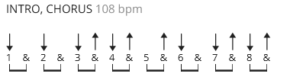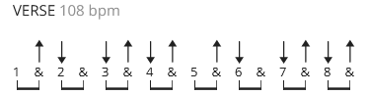

[Intro]
G Am C G

[Verse 1]
F C G
Standin' on a bridge, see the water keep flowin' by, by
F C G
I flipped a quarter in the river, then I headed for the other side, side
F C C
I made the same wish that I always do
Em Em C
I'm just fool enough to think they ever come true
D
Came in like a lion, now I'm out like a lamb
D
They don't even know who I am

[Chorus]
G
Miles and miles wide open for me
Am
Got it all laid out so beautifully
C G
Don't you worry 'bout a thing, baby, we can run away from it all

[Verse 2]
F C G
Old ghost whistle in the wind in the dead of night, night
F C G
I'm walkin' through the valley of the shadow headin' for the light, light
F C C
I wore out my welcome like I always do
Em Em C
Got to find myself a life that's shiny new

D
They say that the truth is gonna set us free
D
I ain't waitin' 'round to see

[Chorus]
G
Miles and miles wide open for me
Am
Got it all laid out so beautifully
C G
Don't you worry 'bout a thing, baby, we can run away from it all
G
Squeezin' every drop outta what's left of my time
Am
Jumpin' on tormorrow before it goes by
C G
No matter what they say, babe, we can run away from it all

[Bridge]
Bb Bb Bb Bb x2
D D D

[Chorus]
G
Miles and miles wide open for me
Am
Got it all laid out so beautifully
C G
Don't you worry 'bout a thing, baby, we can run away from it all
G
Squeezin' every drop outta what's left of my time
Am
Jumpin' on tormorrow before it goes by
C G
No matter what they say, babe, we can run away from it all

[Outro Lead]
Same chord pattern as one full chorus then begin to fade out

