Runaway Del Shannon key Am

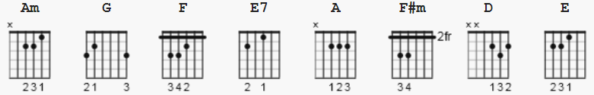

Capo: 1st fret

[Intro] Am G F

[Verse]
Am G
As I walk along, I wonder what went wrong
F
With our love
E7
A love that was so strong.
Am G
And as I still walk on, I think of, the things
F
We`ve done to-gether
E7
while our hearts were young.

[Chorus]
A
I`m walking in the rain
F#m
Tears are falling and I feel the pain
A
Wishing you were here by me
F#m
To end this misery.

A F#m
I wonder I wa-wa-wa-wa-wonder?
A F#m
Why? Wha, wha, wha, wha, why, she ran away?
D E7
And I wonder, where she will stay-yay
A D A E7
My little runaway run, run, run, run, runaway.

[Interlude]
Am G F E E7
Am G F E E7
[Play Chorus Again]

[Outro]
D A
Run, run, run, run, runaway
D A
Run, run, run, run, runaway

