New San Antonio Rose Bob Wills & His Texas Playboys

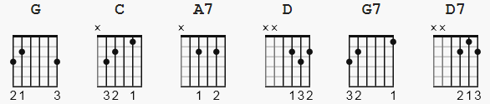

[Verse]
G C A7
Deep within my heart, lies a melo-dy
D G
a song of old San Antone.
C A7
Where in dreams I live with a memo-ry
D G
beneath the stars all alone.
C A7
It was there I found, beside the Alamo
D G
enchantment strange as the blue up above
G7 C A7
a moonlit pass that only she would know.
D G
Still hears my broken song of love.
D
Moon in all your splendor
A7
Know only my heart
D
Call back my rose, Rose of San Antone
Lips so sweet and tender
A7
Like petals fallin' apart
D D7
Speak once again of my love, my own
G C A7
A broken song, empty words I know
D G
That live in my heart all alone
C A7
For that moonlit path beside the Alamo
D G
And Rose, my Rose of San Antone.

