San Francisco Scott McKenzie key Em

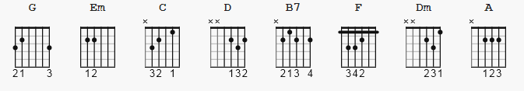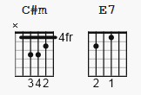

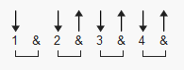 113 bpm ( until this line is erased, I don;t like the cord placements in this version )

[Intro]
G

[Verse]

Em C G D
If you're going to San Francis-co,
Em C G D
Be sure to wear some flowers in your hair,
Em G C G
If you're going to San Francis-co,
Em Bm C D
You're gonna meet some gentle people there.

[Chorus]
Em C G D
For those who come to San Francisco,
Em C G D
Summer time will be a love-in there,
Em G C G
In the streets of San Francis-co,
Em Bm C D
Gentle people with flowers in their hair.

[Bridge]
F Dm
All across the na-tions,
F Dm
Such a strange vibra-tion,
G
People in motion,
F Dm
There's a whole genera-tion,
F Dm
With a new explana-tion,
G
People in motion,
D
People in motion,
[verse]

Em C G D
For those who come to San Francis-co,
Em C G D
Be sure to wear some flowers in your hair,
Em G C D
If you come to San Francis-co,
Em Bm Em G Em
Summer time will be a love-in there,

[Outro]

F#m A D A
If you come to San Francis-co
C#m F#m A F#m
Summer time will be a love-in there

[finis]

A F#m 3X

