Seasons In The Sun Terry Jacks

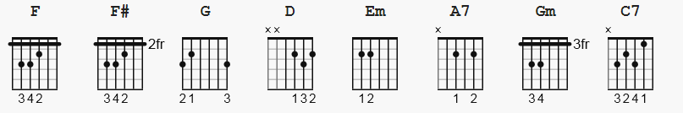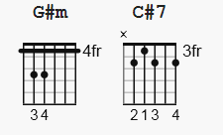

A7* chords are optional, but I think they sound good if you play a solo guitar. =)

Capo on 4th fret for original key.

Intro: | F F# G F | F F# G F | F F# G D |

D
Goodbye to you my trusted friend.
Em
We've known each other since we were nine or ten.
A7* D
Together we climbed hills and trees.
Em A7 D
Learned of love and A-B-C, skinned our hearts and skinned our knees.
D Em
Goodbye my friend it's hard to die, when all the birds are singing in the sky.
A7* D
now that the spring is in the air.
Em A7 D
Pretty girls are everywhere, think of me and I'll be there.

D Em
We had joy, we had fun. We had seasons in the sun,
A7 D | F F# G D |
but the hills that we climb were just seasons out of time.

D Em
Goodbye papa, please pray for me. I was the black sheep of the family.
A7* D
You tried to teach me right from wrong.
Em A7 D
Too much wine and too much song, wonder how I got along.
D Em
Goodbye papa, it's hard to die, when all the birds are singing in the sky.
A7* D
Now that the spring is in the air.
Em A7 D
Little children everywhere, when you see them I'll be there.

D Em
We had joy, we had fun. We had seasons in the sun,
A7 D
but the wine and the song like the seasons have all gone.

F Gm
We had joy, we had fun. We had seasons in the sun,
C7 F | F F# G D |
but the wine and the song like the seasons have all gone.

D Em
Goodbye Michelle, my little one. You gave me love and helped me find the sun.
A7* D
And every time that I was down,
D Em A7 D
you would always come around and get my feet back on the ground.
D Em
Goodbye Michelle it's hard to die, when all the birds are singing in the sky.
A7* D
now that the spring is in the air.
Em A7 D
With the flowers everywhere, I wish that we could both be there.

D Em
We had joy, we had fun. We had seasons in the sun,
A7 D
but the stars we could reach were just starfish on the beach.
F ´ Gm
We had joy, we had fun. We had seasons in the sun,
C7 F
but the stars we could reach were just starfish on the beach.
F# G#m
We had joy, we had fun. We had seasons in the sun,
C#7 F#
but the wine and the song like the seasons have all gone.
F# G#m
All our lives we had fun, we had seasons in the sun,
C#7 F#
but the hills that we climb were just seasons out of time.

FADE OUT

END

