Shakin Hands With The Heavenly Ghost Blackberry Smoke

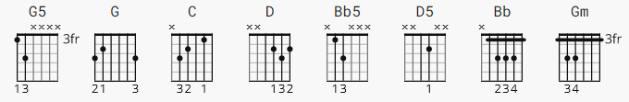

[Intro]
G5 G5 G5 G5
G5 G5 G5 G
G G G G
G

[Verse]

C G D C
Spend the night like wide open
G D
I ain't got nowhere to go
C G Bb5 C
Yeah my baby's howlin' at me
G
Yeah she tearing up the floor

[Instrumental]

G G G G C

[Verse]

G D5 C
We got the Tennessee champagne
G G5 D C
Feeling' moonshine fine
G G5 Bb C
Yeah, my Johnson City baby
G C
Yeah she helps me draw the line

[Pre-Chorus]

C C
As the crow flies baby
C D
Gonna get me apart time
D G D G5
Gonna light me up here
D G
Like the 4th of July...

[Chorus]

G G
Everybody knows, baby take it slow
C
Feel just like I'm singing
Bb
With the heavenly host
G G
Everybody said, everybody knows
C
Just like shaking hands
Bb D C
With the Holy Ghost

[Verse]

G D C
She got the stuff that I need
G D
Keeps me coming back for more
C G G5 Bb C
I ain't ever gonna break away
G C
Got her hook in me for sure

[Pre-Chorus]

C C
As the crow flies baby
C D
Gonna get me up on time
D D
Gonna light me up here
D
Like the 4th of July

[Chorus]

G G
Everybody knows, baby take it slow
C
Feel just like I'm singing
G
With the heavenly host
G G
Everybody said, everybody knows
C
Just like shaking hands
Bb G
With the Holy Ghost

[Bridge]
G G
Alright
G
Mmm, yeah
G G G G

[Solo]

C C C C
D D D D

[Chorus]

Gm G G
Everybody knows, baby take it slow
C
Feel just like I'm singing
Bb
With the heavenly host
Gm G G
Everybody said, everybody knows
C
Just like shaking hands
Bb
With the Holy Ghost
G5 G
Everybody knows, baby take it slow
G G5
Feel just like I'm singing
G5
With the heavenly host
G5 G
Everybody said, everybody knows
C Gm
Just like shaking hands
Gm
With the Holy Ghost

[Outro]

G5 G5 G5 G5 G5

