She's Not There The Zombies 1964 key A or Am

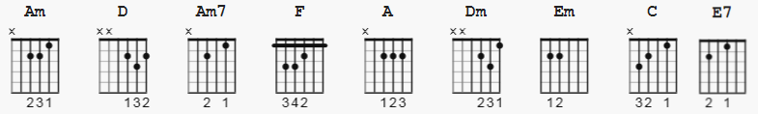 132 bpm

Strum: assume 2/4 time; D Du or try old faithful or cha cha
Several lines have hints you can include in other sections

[INTRO]

Am D Am D [beats start on &1, 1 bar each]

[verse 1]

Am D Am7 D Am F Am D
Well, no one told me about her, the way she lied
Am D Am7 D Am F A (D DuDuDu)
Well, no one told me about her, how many people cried

[Bridge 1]

A D Dm Am
But it's too late to say you're sorry
Am Em Am
How would I know, why should I care?
Am D Dm C
Please don't bother tryin' to find her
C E7 E7
She's not there

[Chorus 1]

E7 Am D
Well, let me tell you 'bout the way she looked
D Am F Am
The way she'd acted and the color of her hair
D Am
Her voice was soft and cool
F Am
Her eyes were clear and bright
D A
But she's not there

Am D Am [beats start on &1, 1 bar each]

[Verse 2]

Am D Am7 D Am F Am D
Well, no one told me about her, what could I do?
Am D Am7 D Am F A
Well, no one told me about her, though they all knew

[Bridge 2]

D Dm Am
But it's too late to say you're sorry
Em Am
How would I know why should I care?
D Dm C
Please don't bother tryin' to find her
E7 E7
She's not there

[Chorus 2]
Am D
Well, let me tell you 'bout the way she looked
Am F Am D
The way she'd acted and the color of her hair
Am F
Her voice was soft and cool
Am D
Her eyes were clear and bright
A
But she's not there

[Instrumental Break]: 2 beats silence, 9 bars medly, start lyric beat
3 on 10th

[Bridge 3]

D Dm Am
But it's too late to say you're sorry
Em Am
How would I know why should I care?
D Dm C
Please don't bother tryin' to find her
E7
She's not there

[Chorus 3]
Am D
Well, let me tell you 'bout the way she looked
Am F Am D
The way she'd acted and the color of her hair
Am F
Her voice was soft and cool
Am D
Her eyes were clear and bright
A [ ends on beat 5]
But she's not there

possible [Intro]s next sheet.

-------------------------------------------------

[ INTRO 1 ]

[Intro from a Gm key - PSE translate !! ] ( font 11pt. )

e|--------------------------------------------------------------------3---|
B|----------3------------------------3---------3----------------------3---|
G|-------3------5-----------------3-----5-----------------------------0---|
D|---5---------------3---5----5-----------------------3----5----------0---| x4
A|-----------------5------------------------------5-------------------x---|
E|--------------------------------------------------------------------3---|

[INTRO 2 ]

