Sister Golden Hair America key (C Am F G) ?? +4 ?

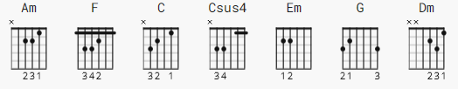

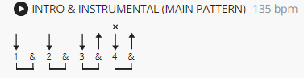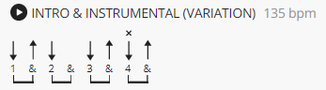

Capo at 4th

[Intro] (tab relative to capo)

Am F C Csus4 C Em
e|-------------------------------------7~--------|
B|----------------------------------8------------|
G|------------------------------7/9--------------|
D|-----------------------------------------------|
A|-----------------------------------------------|
E|-----------------------------------------------|

(Em) Am G F
e|-----------8~------8\7-7~------7\5-5~----------|
B|--------8--------------------------------------|
G|----7/9----------------------------------------|
D|-----------------------------------------------|
A|-----------------------------------------------|
E|-----------------------------------------------|

[Verse 1]

C Em
Well, I tried to make it Sunday, but I got so damn depressed,
F C Em
that I set my sights on Monday and I got myself undressed
F Dm Am Em F
I ain't ready for the altar, but I do agree there's times,
Dm F C Csus4 C
when a woman sure can be a friend of mine

[Verse 2]

C Em
Well, I keep on thinkin' 'bout you, Sister Golden Hair surprise,
F C Em
and I just can't live without you; can't you see it in my eyes?
F Dm Am Em F
I been one poor correspondent, and I been too, too hard to find,
Dm F C
but it doesn't mean you ain't been on my mind
[Chorus]

G F C
Will you meet me in the middle, will you meet me in the air?
G F C
Will you love me just a little, just enough to show you care?
Dm Em F
Well I tried to fake it, I don't mind sayin', I just can't make it

[Instrumental]

Am F C Csus4 C
Em Am G F

(repeat intro riff)

[Verse 4]

C Em
Well, I keep on thinkin' 'bout you, Sister Golden Hair surprise,
F C Em
and I just can't live without you; can't you see it in my eyes?
F Dm Am Em F
I been one poor correspondent, and I been too, too hard to find,
Dm F C
but it doesn't mean you ain't been on my mind

[Chorus]

G F C
Will you meet me in the middle, will you meet me in the air?
G F C
Will you love me just a little, just enough to show you care?
Dm Em F
Well I tried to fake it, I don't mind sayin', I just can't make it

[Outro]

G F C
Doo wop shoo wop, Doo wop shoo wop, Doo wop shoo wop, Doo wop shoo wop
G F C
Doo wop shoo wop, Doo wop shoo wop, Doo wop shoo wop, Doo wop shoo wop
G F C
Doo wop shoo wop, Doo wop shoo wop, Doo wop shoo wop, Doo wop shoo wop
G F C
Doo wop shoo wop, Doo wop shoo wop, Doo wop shoo wop, Doo wop shoo wop

