Sloop John B Beach Boys key A

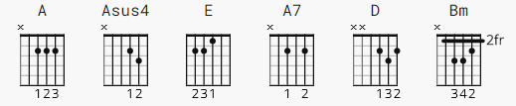 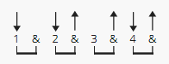 130 bpm

[Intro riff 4x]

A A A A

[Verse 1]

A Asus4 A
We come on the sloop John B
Asus4 A
My grandfather and me
E
Around Nassau town we did roam
A A7
Drinking all night
A7 D Bm
Got into a fight
A
Well I feel so broke up
E A
I want to go home

[Chorus]

A Asus4 A
So hoist up the John B’s sail
Asus4 A
See how the main sail sets

Call for the captain ashore
E A A7
Let me go home, let me go home
D Bm
I wanna go home, yeah yeah
A
Well I feel so broke up
E A
I wanna go home

[Verse 2]

A Asus4 A
The first mate he got drunk
A Asus4 A
And broke in the capn’s trunk
E
The constable had to come and take him away
A A7
Sheriff John Stone
A7 D Bm
Why don’t you leave me alone, yeah yeah
A E A
Well I feel so broke up I wanna go home

[Chorus]

A Asus4 A
So hoist up the John B’s sail
A Asus4 A
See how the main sail sets

Call for the captain ashore
E A A7
Let me go home, let me go home
D Bm
I wanna go home, yeah yeah
A
Well I feel so broke up
E A
I wanna go home

[Verse 3]

A Asus4 A
The poor cook he caught the fits
A Asus4 A
And threw away all my grits
E
And then he took and he ate up all of my corn
A A7
Let me go home
D Bm
Why don’t they let me go home
A E A
This is the worst trip I’ve ever been on

[Chorus]

A Asus4 A
So hoist up the John B’s sail
A Asus4 A
See how the main sail sets

Call for the captain ashore
E A A7
Let me go home, let me go home
D Bm
I wanna go home, yeah yeah
A
Well I feel so broke up
E A
I wanna go home
A
Well I feel so broke up
E A
I wanna go home
A
Well I feel so broke up
E A
I wanna go home

