Solitary Man Neil Diamond key Em

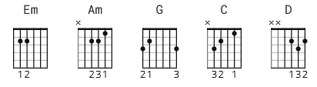 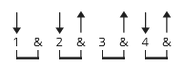 157 bpm

[Intro][riff]

e|3---3p0---2-2p0-|------0-------0-|e
B|5-------5-------|----5-------0---|B
G|----------------|4-------0h2-----|G
D|----------------|----------------|D
A|----------------|----------------|A
E|----------------|----------------|E

After this play with an Em and an Em-add-G before going into the verse.
Em-add-G: 0 2 2 0 0 3

[Intro]

Em

[Verse 1]

Em Am G Em G
Melinda was mine 'til the time that I found her
Am G
Holdin' Jim
Am Em
Lovin' him
Am G Em G
Then Sue came a-long, loved me strong, that's what I thought
Am G
But me and Sue
Am
That died too

[Chorus]

G C G D
Don't know that I will, but un-til I can find me
C G D
A girl who'll stay and won't play games be-hind me
Em D
I'll be what I am
Em D Em
A solitary man... Solitary man

[Verse 2]

Em Am G Em G
I've had it to here being where love's a small word
Am G
A part time thing
Am Em
A paper ring
Am G Em G
I know it's been done havin' one girl who loves you
Am G Am
Right or wrong Weak or strong

[Chorus]

G C G D
Don't know that I will, but un-til I can find me
C G D
A girl who'll stay and won't play games be-hind me
Em D
I'll be what I am
Em D Em
A solitary man... Solitary man

[Instrumental]

Em Am Em Am

[REPEAT CHORUS]

[Outro]

D Em D Em D Em D Em D
Mmm-Mmm-Mmm-Mmm Solitary man Mmm-Mmm-Mmm-Mmm Solitary man

-----------------------
alternate Intro

e|-3---3p0---2-2-0-|-------0-------0-|-------0---------|-------3---0-----|
B|-5-------5-------|-----5-------0---|-0---------0---0-|---------------0-|
G|-----------------|-4-------0h2-----|-0---0-----------|-----------------|
D|-----------------|-----------------|-2-------2---2---|-----2---2---2---|
A|-----------------|-----------------|-----------------|-----------------|
E|-----------------|-----------------|-----------------|-0---------------|

