Sound Of Silence - Simon (needs work) Capo on 7 matches video

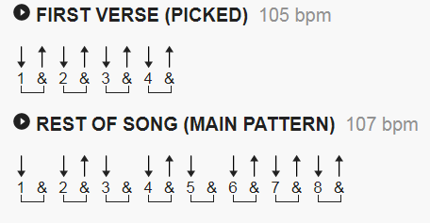

Intro: Am
Am G Am
Hello darkness, my old friend, I've come to talk with you again,
C F C F C
Because a vision softly creeping, left its seeds while I was sleeping,
F C Am C
And the vision that was planted in my brain still remains,
G Am
Within the sound of silence.

Am G Am
In restless dreams I walked alone, narrow streets of cobblestone,
C F C
'Neath the halo of a street lamp,
C F C
I turned my collar to the cold and damp
F F C
When my eyes were stabbed by the flash of a neon light
C AM
that split the night
G Am
And touched the sound of silence.

Am G Am
And in the naked light I saw ten thousand people, maybe more,
C F C F C
People talking without speaking, people hearing without listening,
F F C C Am C
People writing songs that voices never share, and no one dare,
C G Am
Disturb the sound of silence.

Am G Am
"Fools!" said I, "You do not know, silence like a cancer grows."
C F C
"Hear my words that I might teach you,
C F C
take my arms that I might reach you."
F F C Am
But my words like silent raindrops fell,
C G Am
and echoed in the wells of silence.

Am G Am
And the people bowed and prayed to the neon god they made,
C F C F C
And the sign flashed out its warning, in the words that it was forming,
F F
And the signs said "The words of the prophets are written
C Am
On the subway walls, and tenement halls"
C G Am
And whisper'd in the sounds of silence.

NOTE: this is a WORD document. lines have reduced font size from 12 to 11

