Sound Of Silence - Simon key G Capo on 6 matches video

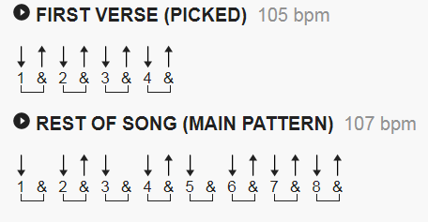
To make counting easier, bars indicated are the double speed.

[Verse 1]

Am G
Hello darkness, my old friend,
Am
I've come to talk with you a-gain,
C F C
Because a vision softly creep-ing,
F C
Left its seeds while I was sleep-ing,
F C
And the vision that was planted in my brain
C/B Am
Still remains
C G Am
Within the sound of si-lence.

[Verse 2]

Am G
In restless dreams I walked a-lone
G Am
Narrow streets of cobbles-tone,
F C
'neath the halo of a street lamp,
F(1) C (2)
I turned my collar to the cold and damp
F(4) C(2)
When my eyes were stabbed by the flash of a neon light
|C/B |Am|
That split the night
C(1) G(2) Am(2)
And touched the sound of silence.

[Verse 3]

Am G
And in the naked light I saw
G Am
Ten thousand people, maybe more.
F C
People talking without speak-ing,
F C
People hearing without lis-ten-ing,
F C
People writing songs that voices never share
C/B Am
And no one dare
C G Am
Disturb the sound of silence.

[Verse 4]

Am G
Fools said I, you do not know
Am
Silence like a cancer grows.
C F C
Hear my words that I might teach you,
F C
Take my arms that I might reach you.
F C C/B Am
But my words like silent raindrops fell,
C
And echoed
G Am
In the wells of si-lence

[Verse 5]

Am G
And the people bowed and prayed
Am
To the neon God they made.
C F C
And the sign flashed out its warn-ing,
F C
In the words that it was form-ing.
F
And the sign said, the words of the prophets
C
Are written on the subway walls
C/B Am
And tenement halls.
C G Am
And whisper'd in the sounds of silence.

