Stand By Me Ben E. King

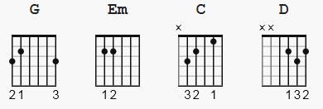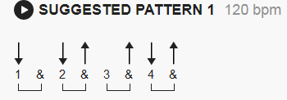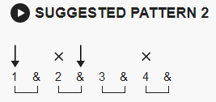

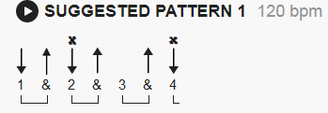

[Intro]

G G Em Em C D G G (Justin's G = 320033)

[Verse]

G Em
When the night has come and the land is dark
C D G
and the moon is the only light we'll see
G Em
No, I won't be afraid, oh I won't be afraid
C D G (add D here optional)
just as long as you stand, stand by me

[Chorus]

G G Em
So darling, darling, stand by me, oh stand by me
C D G
Oh stand, stand by me, stand by me

[Verse]

G Em
If the sky that we look upon should tumble and fall
C D G
or the mountain should crumble to the sea
G Em
I won't cry, I won't cry, no I won't shed a tear
C D G
just as long as you stand, stand by me

[Chorus]

G Em
And darling, darling, stand by me, oh stand by me
C D G
Oh stand now, stand by me, stand by me

[Instrumental]

G G Em Em C D G G
G G Em Em C D G

[Chorus]

G G Em
Darling, darling, stand by me, oh stand by me
C D G
Oh stand now, stand by me, stand by me

Whenever you're in trouble would you
G Em
stand by me, oh stand by me
C D G
Oh, would you stand now, oh stand, stand by me

