Stormy Classics IV

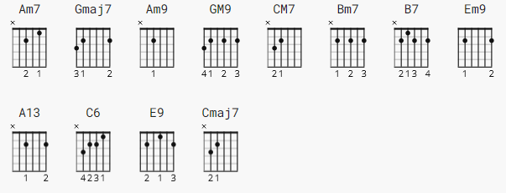
https://www.youtube.com/watch?v=18Sua_QTDs0

[Intro]

Am7 Gmaj7 Am7 Gmaj7

[Verse 1]

Am9 GM9 Am9 GM9
You were the sunshine, baby, whenever you smiled.
Am9 GM9 CM7
But I call you Stormy, today.
Am9 GM9 Am9 GM9
All of a sudden that old rain's falling down..
Am9 GM9 CM7 Bm7 B7
And my world is cloudy and gray..you've gone away.

[Chorus]

Em9 A13 Em9 A13 C6 Bm7 GM9 E9 A13
Oh Stor..my, oh, Stor..my...Bring back that sunny day.

[Verse 2]

Am9 GM9 Am9 GM9
Yesterday's love was like a warm summer breeze.
Am9 GM9 CM7
But, like the weather, you changed.
Am9 GM9 Am9 GM9
Now things are dreary, baby, and it's windy and cold.
Am9 GM9 CM7 Bm7 B7
And I stand alone in the rain..calling your name.

[Chorus]

Em9 A13 Em9 A13 C6 Bm7 GM9 Em9 A13
Oh Stor..my, oh, Stor..my...Bring back that sunny day.

[Sax Solo]

Am7 Gmaj7 Am7 Gmaj7
Am7 Gmaj7 Cmaj7
Bm7 B7

[Chorus]

Em9 A13 Em9 A13 C6 Bm7 GM9 Em9 A13
Oh Stor..my, oh, Stor..my...Bring back that sunny day.

[Outro]

C6 Bm7 GM9 E9 A13
Bring back that sunny day.
Em9 A13 Em9 A13
Oh, Stor..my..Oh, Stor..my..(Fade.)

