Sweet Home Alabama Lynyrd Skynyrd

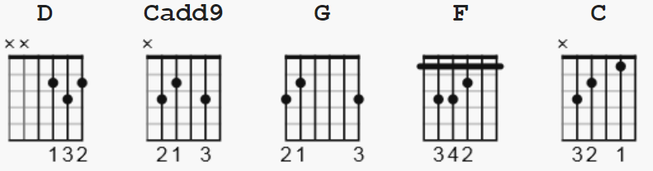

D= 222232 Cadd9= 032033 G= 320033 beginners use normal open C

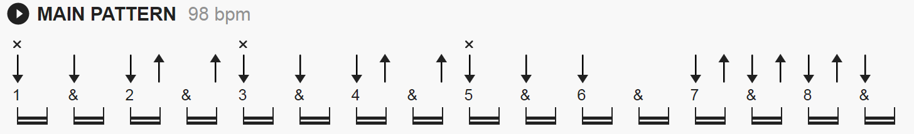

Intro Riff]

e|-------------------------3-|
B|-----3---------3---------3-|
G|-------2----------0------0-| x4
D|-0-0---------------------0-|
A|----------3-3------------2-|
E|---------------------3-3-3-|

[Intro]
D Cadd9 G x4

[Verse]
D Cadd9 G
Big wheels keep on turning
D Cadd9 G
Carry me home to see my kin
D Cadd9 G
Singing songs about the south land
D Cadd9 G
I miss 'ole' 'bamy once again and I think it's a sin

[Interlude]
D Cadd9 G
D Cadd9 G

[Verse]
D Cadd9 G
Well I heard Mr. Young sing about her
D Cadd9 G
Well I heard old Neil put her down
D Cadd9 G
Well I hope Neil Young will remember
D Cadd9 G
A southern man don’t need him around, anyhow

[Chorus]
D Cadd9 G D Cadd9 G
Sweet home Alabama, where the skies are so blue
D Cadd9 G D Cadd9 G
Sweet home Alabama, Lord I’m coming home to you

[Solo]
F C
D Cadd9 G
D Cadd9 G

[Verse]
D Cadd9 G F C D
In Birmingham they love the Gov'nor, boo-hoo-hoo
(D) Cadd9 G
Now we all did what we could do
D Cadd9 G
Now watergate does not bother me
D Cadd9 G
Does you conscience bother you (tell the truth!)

[Chorus]
D Cadd9 G D Cadd9 G
Sweet home Alabama, where the skies are so blue
D Cadd9 G D Cadd9 G
Sweet home Alabama, Lord I’m coming home to you
(Here I come, Alabama)

[Solo]
D Cadd9 G D Cadd9 G D Cadd9 G D Cadd9 G D Cadd9 G
D Cadd9 G D Cadd9 G D Cadd9 G D Cadd9 G D Cadd9 G

[Verse]
D Cadd9 G
Now Muscle Shoals has got the swampers
D Cadd9 G
And they've been known to pick a song or two (yes we do)
D Cadd9 G
Lord they get me off so much
D Cadd9 G
They pick me up when I'm feeling blue, now how 'bout you?

[Chorus]
D Cadd9 G D Cadd9 G
Sweet home Alabama, where the skies are so blue
D Cadd9 G D Cadd9 G F C
Sweet home Alabama, Lord I’m coming home to you

[Outro]
D Cadd9 G
Sweet home Alabama (Oh, sweet home baby)
D Cadd9 G
Where the skies are so blue (And the governor's true)
D Cadd9 G
Sweet Home Alabama, (Lord, yeah)
D Cadd9 G
Lord, I'm coming home to you (Yeah, yeah)

[Outro]
D Cadd9 G D Cadd9 G D Cadd9 G D Cadd9 G

