Sweet Home Chicago Eric Clapton

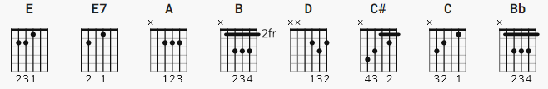

[Intro]
E E E E7
A A E E
B A E D C# C B Bb B

[Verse 1]
E A E7
Come on, baby don't you want to go
A E
Come on, baby don't you want to go
B
Back from the land of California
A E D C# C B Bb B
To my sweet home, Chicago

[Verse 2]
E A E E7
Come on, baby don't you want to go
A E
Come on, baby don't you want to go
B
Back from the land of California
A E D C# C B Bb B
To my sweet home, Chicago

[Verse 3]
E
Two and two is four babe, six and two is eight
E7
Come on now darlin', don't you make me late
A E
I'm cryin' please, baby, don't you want to go
B
Back from the land of California
A E D C# C B Bb B
To my sweet home, Chicago

[Instrumental]
E A E E7
A A E E
B A E D C# C B Bb B
E A E E7
A A E E
B A E D C# C B Bb B

[Verse 4]
E
One and one is two, two and two is four
E7
I'm heavy loaded baby, I'm booked, I gotta go
A E
I'm cryin' please, baby, don't you want to go
B
Back from the land of California
A E D C# C B Bb B
To my sweet home, Chicago

[Instrumental]
E A E E7
A A E E
B A E D C# C B Bb B
E A E E7
A A E E
B A E D C# C B Bb B

[Verse 5]
E A E E7
Come on, baby don't you want to go
A E
Come on, baby don't you want to go
B
Back from the land of California
A E D C# C B Bb B
To my sweet home, Chicago

[Verse 6]
E A E E7
Come on, baby don't you want to go
A E
Come on, baby don't you want to go
B
Back from the land of California
A E D C# C B Bb B
To my sweet home, Chicago

[Outro]
E A E E7
A A E E
B A E D C# C B E7
-----------------------------------------------
NOTEs:
substitute
E7 for E or for 5 chords, E5
A7 for A A5
B7 for B
C7 for C
D7 for D

turn around:

