Tennessee Whiskey George Jones key F w/keychange

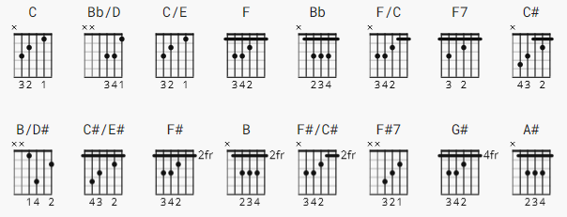 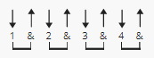 105bpm

B/D# = can be xx1x02; time signature feels like 4/4, unlike Stapleton

[Verse]

C Bb/D C/E F Bb F
I used to spend my nights out in a barroom
Bb F C
Liquor was the only love I'd known
F Bb F
But you rescued me from reaching for the bottom
Bb F/C C F
And you brought me back from being too far gone

[Chorus]

Bb C F Bb F
You're as smo-oth as Tennessee whiskey
C
You're as sweet as strawberry wine
F F7 Bb
You're as warm as a glass of brandy
F C F
And I stay stoned on your love all the time

[Instrumental] keychange here
Bb F C F C#

[Verse]

B/D# C#/E# F# B F#
I looked for love in all the same ol' places
B F# C#
Found the bottom of the bottle always dry
F# B F#
But when you poured out your heart I didn't waste it
B F#/C# C# F#
'Cause there's nothing like your love to get me high

[Chorus]

B C# F# B F#
You're as smo-oth as Tennessee whiskey
C#
You're as sweet as strawberry wine
F# F#7 B
You're as warm as a glass of brandy
F# C# F#
And I stay stoned on your love all the time

[Outro]

G# A# B C# B/D# C#/E# F# C# B F#
I stay stoned on your love all the ti-me

---------------------------
(from another UG version)

[Solo]

e|------13-------------------------8---------------------------------|
B|-13b15--15r13----pbr8-6------8b10-10r8-6---------------------------|
G|-----------------------7-5-----------------------------------------|
D|-------------------------------------------------------------------|
A|-------------------------------------------------------------------|
E|-------------------------------------------------------------------|

************************************
| r Release
| b Bend
| pbr Pre-bend release
************************************

