Tequila Sunrise the Eagles key G

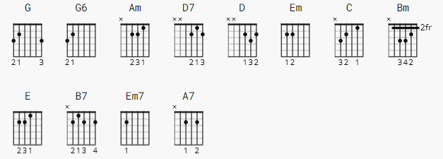

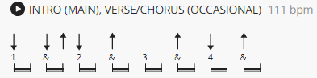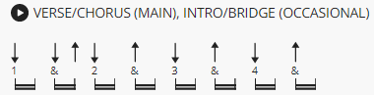

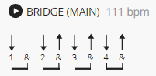 no capo note: all G, G6 are 1 bar |G G6|
D(2) indicates D is 2 bars

[Intro]

G G6 G G6 G G6 G G6
Am D7 G G6 G G6

[Verse 1]

|G G6 | G G6 |
It's another tequila sunrise
D(2) Am(1)
Starin' slowly 'cross the sky
D7 G G6 G G6
Said goodbye
G G6 G G6
He was just a hired hand
D(2) Am(1)
Workin' on the dreams he planned to try
D7 G G6 G G6
The days go by

[Chorus]

Em(1) C(1)
Every night when the sun goes down
Em C
Just another lonely boy in town
Em(1) Am(1) D7(2)
and she's out runnin' round

[Verse 2]

G G6 G G6
She wasn't just another woman
D Am
And I couldn't keep from comin' on
D7 G G6 G G6
It's been so long
G G6 G G6
Oh, and it's a hollow feelin'
D Am
When it comes down to dealin' friends
D7 G G6 G G6
It never ends

[Solo]

G G6 G G6
D D
Am D7
G G6 G G6

[Bridge]

Am D
Take another shot of courage
Bm E Am B7
Wonder why the right words never co - ome
Em7 A7
You just get numb

[Verse 3]

G G6 G G6
It's another tequila sunrise
D Am
This old world still looks the same
D7 G G6 G G6
Another frame

[Outro]

G G6 G G6
G G6 G G6 G

