The Weight key A The Band

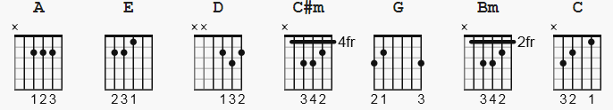

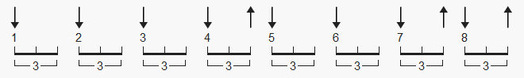 one suggested strum pattern, 144 bpm

[Intro] ( simple )

E|--------------------------------------------------------------------|
B|-------------10-----------------------------------------------------|
G|------9-9h11----9h11-9--------9-------------------------------------|
D|-9h11-------------------9h11-----7h9--7h9--7----------2-------------|
A|----------------------------------------------2--2h4----4-2-0-------|
e|--------------------------------------------------------------------|

[verse 1]

A C#m D A
I pulled into Nazareth, was feelin' about half past dead;
C#m D A
I just need some place where I can lay my head.
C#m D A
"Hey, mister, can you tell me where a man might find a bed?"
C#m D A
He just grinned and shook my hand, and "No!", was all he said.

[chorus ]

A E D A E D
Take a load off Fanny, take a load for free;
A E D A
Take a load off Fanny, and (and) (and) you can put the load right on me.

[Instrumental]

A E D A D

[verse 2]

A C#m D A
I picked up my bag, I went lookin' for a place to hide;
C#m D A
When I saw Carmen and the Devil walkin' side by side.
C#m D A
I said, "Hey, Carmen, come on, let's go downtown."
C#m D A
She said, "I gotta go, but m'friend can stick around."

[chorus]

A E D A E D
Take a load off Fanny, take a load for free;
A E D A
Take a load off Fanny, and (and) (and) you can put the load right on me.

[Instrumental]

A E D A D

[verse 3]

A C#m D A
Go down, Miss Moses, there's nothin' you can say
C#m D A
It's just ol' Luke, and Luke's waitin' on the Judgement Day.
C#m D A
"Well, Luke, my friend, what about young Anna Lee?"
C#m D A
He said, "Do me a favor, son, woncha stay an' keep Anna Lee company?"

[chorus]

A E D A E D
Take a load off Fanny, take a load for free;
A E D A
Take a load off Fanny, and (and) (and) you can put the load right on me.

[Instrumental]

A E D A D

[verse 4]

A C#m D A
Crazy Chester followed me, and he caught me in the fog.
C#m D A
He said, "I will fix your rack, if you'll take Jack, my dog."
C#m D A
I said, "Wait a minute, Chester, you know I'm a peaceful man."
C#m D A
He said, "That's okay, boy, won't you feed him when you can."

[chorus]

A E D A E D
Take a load off Fanny, take a load for free;
A E D A
Take a load off Fanny, and (and) (and) you can put the load right on me.
[Instrumental]

A E D A D

[verse 5]

A C#m D A
Catch a cannon ball now, t'take me down the line
C#m D A
My bag is sinkin' low and I do believe it's time.
C#m D A
To get back to Miss Fanny, you know she's the only one.
C#m D A
Who sent me here with her regards for everyone.

[chorus]

A E D A E D
Take a load off Fanny, take a load for free;
A E D A
Take a load off Fanny, and (and) (and) you can put the load right on me.

[Outro]
or end ?

--------

[Intro] ( harmony added )

e|--------------------------------------------------------------------|
B|-------------10-----------------------------------------------------|
G|-9----9-9h11----9h11-9--9-----9--7----7----7------------------------|
D|-9h11---9-------9-------9h11-----7h9--7h9--7----------2-------------|
A|----------------------------------------------2--2h4----4-2-0-------|
E|--------------------------------------------------------------------|

a lick for the key of C !! ( yeah yeah, should be in another file )

C | lick | F F F
e|---------0---0----0----------------|
B|---------1---1----1----------------|
G|---------0---0----0----------------|
D|---------0---2----2----------------|
A|---------2---0----0----------------|
E|---------x---x----3----------------|

* Alternate:

Capo II

A = G
C#m = Bm
D = C
E = D

