**The Weight** key A The Band

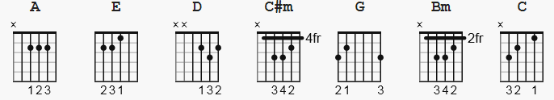

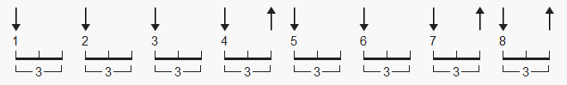 one suggested strum pattern, 144 bpm

[Intro] ( simple )

E|--------------------------------------------------------------------|

B|-------------10-----------------------------------------------------|

G|------9-9h11----9h11-9--------9-------------------------------------|

D|-9h11-------------------9h11-----7h9--7h9--7----------2-------------|

A|----------------------------------------------2--2h4----4-2-0-------|

e|--------------------------------------------------------------------|

[verse 1]

A C#m D A

I pulled into Nazareth, was feelin' about half past dead;

C#m D A

I just need some place where I can lay my head.

C#m D A

"Hey, mister, can you tell me where a man might find a bed?"

C#m D A

He just grinned and shook my hand, and "No!", was all he said.

[chorus ]

A E D A E D

Take a load off Fanny, take a load for free;

A E D A

Take a load off Fanny, and (and) (and) you can put the load right on me.

[Instrumental]

A E D A D

[verse 2]

A C#m D A

I picked up my bag, I went lookin' for a place to hide;

C#m D A

When I saw Carmen and the Devil walkin' side by side.

C#m D A

I said, "Hey, Carmen, come on, let's go downtown."

C#m D A

She said, "I gotta go, but m'friend can stick around."

[chorus]

A E D A E D

Take a load off Fanny, take a load for free;

A E D A

Take a load off Fanny, and (and) (and) you can put the load right on me.

[Instrumental]

A E D A D

[verse 3]

A C#m D A

Go down, Miss Moses, there's nothin' you can say

C#m D A

It's just ol' Luke, and Luke's waitin' on the Judgement Day.

C#m D A

"Well, Luke, my friend, what about young Anna Lee?"

C#m D A

He said, "Do me a favor, son, woncha stay an' keep Anna Lee company?"

[chorus]

A E D A E D

Take a load off Fanny, take a load for free;

A E D A

Take a load off Fanny, and (and) (and) you can put the load right on me.

[Instrumental]

A E D A D

[verse 4]

A C#m D A

Crazy Chester followed me, and he caught me in the fog.

C#m D A

He said, "I will fix your rack, if you'll take Jack, my dog."

C#m D A

I said, "Wait a minute, Chester, you know I'm a peaceful man."

C#m D A

He said, "That's okay, boy, won't you feed him when you can."

[chorus]

A E D A E D

Take a load off Fanny, take a load for free;

A E D A

Take a load off Fanny, and (and) (and) you can put the load right on me.

[Instrumental]

A E D A D

[verse 5]

A C#m D A

Catch a cannon ball now, t'take me down the line

C#m D A

My bag is sinkin' low and I do believe it's time.

C#m D A

To get back to Miss Fanny, you know she's the only one.

C#m D A

Who sent me here with her regards for everyone.

[chorus]

A E D A E D

Take a load off Fanny, take a load for free;

A E D A

Take a load off Fanny, and (and) (and) you can put the load right on me.

[Outro]

or end ?

--------

[Intro] ( harmony added )

e|--------------------------------------------------------------------|

B|-------------10-----------------------------------------------------|

G|-9----9-9h11----9h11-9--9-----9--7----7----7------------------------|

D|-9h11---9-------9-------9h11-----7h9--7h9--7----------2-------------|

A|----------------------------------------------2--2h4----4-2-0-------|

E|--------------------------------------------------------------------|

a lick for the key of C !! ( yeah yeah, should be in another file )

C | lick | F F F

e|---------0---0----0----------------|

B|---------1---1----1----------------|

G|---------0---0----0----------------|

D|---------0---2----2----------------|

A|---------2---0----0----------------|

E|---------x---x----3----------------|

* Alternate:

Capo II

A = G

C#m = Bm

D = C

E = D