Time Of The Season Zombies key Em

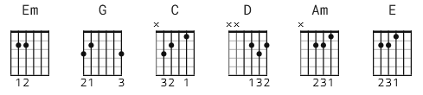

[Intro]
Em

[Verse]

Em Em G C
It's the time, of the season
Em
When the love runs high
Em Em G C
In this time, give it to me easy
Em G
And let me try, with pleasured hands,
Em G
To take you in the sun to promised lands,
Em
To show you everyone

[Chorus]

Em D C G Am E
It's the time of the season for loving

Solo over Verse and Chorus

[Verse]

Em
What's your name? (what's your name)
Em G C
Who's your daddy? (who's your daddy)
Em
Is he rich like me?
Em
Has he taken (has he taken)
Em G C
Any time (any time)
Em G
To show you what you need to live,
Em G
Tell it to me slowly, tell you why,
Em
I really want to know

[Chorus]

Em D C G Am E
It's the time of the season for loving

[Instrumental 1] 16 bars
[Instrumental rhythm] 4 bars

[Verse]

C Em
What's your name? (what's your name)
Em G C
Who's your daddy? (who's your daddy)
Em
Is he rich like me?
Em
Has he taken (has he taken)
Em G C
Any time (any time)
Em G
To show you what you need to live
Em G
Tell it to me slowly, tell you why,
Em
I really want to know

[Chorus]

Em D C G Am E
It's the time of the season for loving

[Outro Instrumental]
26 bars with +2 fade

---------
??[Outro]
Em Em C Em

