Time Pink Floyd

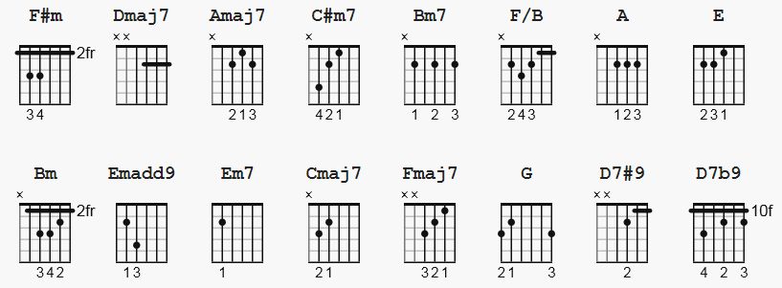
==============

Album: Dark Side of the Moon
Words & Music by Roger Waters, Richard Wright, David Gilmour and Nicholas Mason

F#m Dmaj7 Amaj7 C#m7 Bm7 F/B
(or Fadd#11/B but that won't highlight)

e|-2-------2--------0--------4-------2-------1-----|
B|-2-------2--------2--------5-------3-------1-----|
G|-2-------2--------1--------4-------2-------2-----|
D|-4-------0--------2--------6-------4-------3-----|
A|-4----------------0--------4-------2-------2-----|
E|-2-----------------------------------------------|

[Intro]
(Lead Guitar with percussion)

[Verse 1]

F#m A
Ticking away the moments that make up a dull day
E F#m
Fritter and waste the hours in an offhand way
F#m A
Kicking around on a piece of ground in your hometown
E F#m
Waiting for someone or something to show you the way

[Chorus]

Dmaj7 Amaj7
Tired of lying in the sunshine, staying home to watch the rain
Dmaj7 Amaj7
You are young and life is long, and there is time to kill today
Dmaj7 C#m7
And then one day you find, ten years have got behind you
Bm7 E
No one told you when to run ... You missed the starting gun

[Guitar Solo]

F#m A E F#m x4

Dmaj7 Amaj7 Dmaj7 Amaj7 Dmaj7 C#m7 Bm7 E

[Verse 2]

F#m A
And you run and you run to catch up with the Sun, but it's sinking;
E F#m
Racing around to come up behind you again.
F#m A
The Sun is the same in a relative way, but you're older,
E F#m
shorter of breath, and one day closer to death.

Dmaj7 Amaj7
Every year is getting shorter, never seem to find the time.
Dmaj7 Amaj7
Plans that either come to naught, or half a page of scribbled lines.
Dmaj7 C#m7
Hanging on in quiet desperation is the English way.
Bm Bm7 F/B
The time is gone, the song is over. Thought I'd something more to say.

Emadd9 A Emadd9 A

[Verse 3]

Em7 A
Home, home again
Em7 A
I like to be here when I can
Em7 A
When I come home, cold and tired
Em7 A
It's good to warm my bones beside the fire
Cmaj7
Far away, across the field
Bm7
Tolling on the iron bell
Fmaj7
Calls the faithful to their knees
G D7#9 D7b9 Bm
To hear the softly spoken magic spell

X

