Twist and Shout Beatles key D-no Capo (Key A fingering Capo 5)

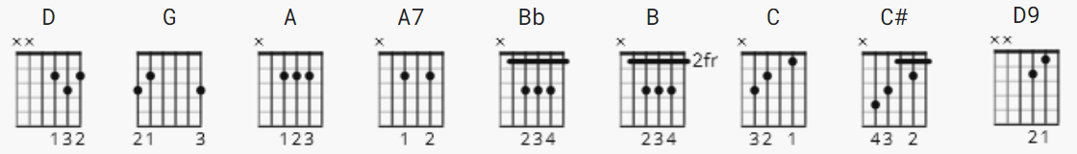

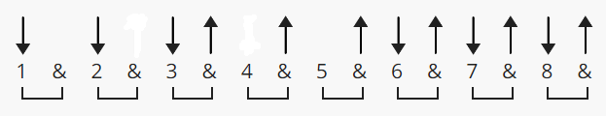 125 bpm ( justin pattern )

[Intro]
D G A
e|------------------------------------------|
B|------------------------------------------|
G|------------------------------------------|
D|---------------7--------------------------|
A|--------4--5---5---2--2---4---4--4--4--4--|
E|--5--7-------------3--3---5---5--5--5--5--|

[Verse 1]
D G A
Well shake it up baby now, (shake it up baby)
A7 D G A
Twist and shout. (Twist and shout)
A7 D G A
Come on, come on, come on, come on, baby now, (come on baby)
D G A
Come on and work it on out. (Work it on out, ooh!)

[Verse 2]
D G A
Well work it on out, (work it on out)
A7 D G A
You know you look so good. (Look so good)
A7 D G A
You know you got me goin' now, (Got me goin')
D G A
Just like I knew you would. (Like I knew you would, ooh!)

[Verse 3]
D G A
Well shake it up baby now, (shake it up baby)
A7 D G A
Twist and shout. (Twist and shout)
A7 D G A
Come on, come on, come on, come on, baby now, (come on baby)
D G A
Come on and work it on out. (Work it on out, ooh!)
[Verse 4]
D G A
You know you twist it little girl, (twist little girl)
A7 D G A
You know you twist so fine. (Twist so fine)
A7 D G A
Come on and twist a little closer now, (twist a little closer)
D G A
And let me know that you're mine. (Let me know you're mine, ooh!)

[Solo Chords]

D G A D G A D G A D G A

[Solo Tab]
e|---------------------------------|
B|-----------3---2-------2---------|
G|---------4-4---2-------2-4---2---| x4
D|-4-----4-5---------------5---4---|
A|-5-----5-------------------------|
E|---------------------------------|

[Bridge]

A A7
Ahh ahh ahh ahh ahh yeah!!

[Verse 5]

D G A
Baby now, (shake it up baby)
A7 D G A
Twist and shout. (Twist and shout)
A7 D G A
Come on, come on, come on, come on, baby now, (come on baby)
D G A
Come on and work it on out. (Work it on out, ooh!)

[Verse 6]
D G A
You know you twist it little girl, (twist little girl)
A7 D G A
You know you twist so fine. (Twist so fine)
A7 D G A
Come on and twist a little closer now, (twist little closer)
D G A
And let me know that you're mine. (Let me know you're mine ooh!)

[Verse 7]
D G A
Well shake it shake it shake it baby now. (shake it up baby)
A7 D G A
Well shake it shake it shake it baby now. (shake it up baby)
A7 D G A
Well shake it shake it shake it baby now. (shake it up baby)
A A7 A Bb B C C# D D9
Ahh ahh ahh ahh

Capo 5 -> D->A G->D A->E ; IOW, I, IV, V => DGA -> ADE

