Wake Up Little Susie Everly Brothers

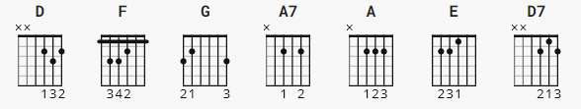
For the RIFF part

D x-x-0-2-3-2
F x-3-3-2-1-1
G x-5-5-4-3-3
A7 x-0-2-0-2-0

(Riff)

D F G F D F G F

[Verse]

D F G F D
Wake up little Susie, wake up
D F G F D
Wake up little Susie, wake up
G D G G D G
We both been sound asleep, wake up little Susie and weep
G D G D G D G
The movie's over, it's four o'clock and we're in trouble deep
A G A
Wake up little Susie, wake up little Susie

[Chorus]

A E A
Well, what're we gonna tell your mamma?
A E A
What're we gonna tell your pa?
A E A N.C.
What're we gonna tell our friends when they say "ooh la la"?
D A7 D
Wake up little Susie, wake up little Susie

[Middle 8]

D D7
Well I told your momma that you'd be in by ten
G
Well now Susie baby looks like we goofed again (tight printing)
A G A (N.C.) D>F G F D F G F
Wake up little Susie, wake up little Susie, we gotta go home

[Verse]

D F G F D
Wake up little Susie, wake up
D F G F D
Wake up little Susie, wake up
G D G G D G
The movie wasn't so hot, it didn't have much of a plot
G D G D G D G
We fell asleep, our goose is cooked, our reputation is shot
A G A
Wake up little Susie, wake up little Susie...

[Chorus/Outro]

A E A
Well, what're we gonna tell your mamma?
A E A
What're we gonna tell your pa?
A E A N.C.
What're we gonna tell our friends when they say "ooh la la"?
D A7 D
Wake up little Susie, wake up little Susie
A7 D D F G D F G D F G D F G
Wake up little Susie (fade)

