Walk Right In, Sit Right Down The Rooftop Singers

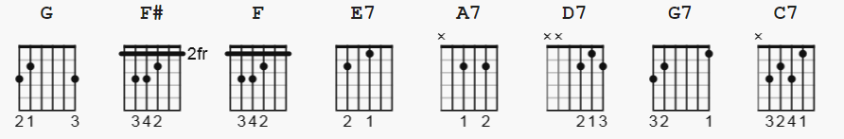

CAPO I key A; finger G

[Introduction]

G G F# F E7 A7 D7 G D7

[Verse 1]

G G F# F E7
Walk right in, sit right down
A7 D7 G D7
Daddy, let your mind roll on
G G F# F E7
Walk right in, sit right down
A7 A7 D7
Daddy, let your mind roll on
G G7
Everybody's talkin' 'bout a new way of walkin'
C7 A7
Do you want to lose your mind?
G G F# F E7
Walk right in, sit right down
A7 D7 G
Daddy, let your mind roll on

[Verse 2]

G G F# F E7
Walk right in, sit right down
A7 D7 G D7
Baby, let your hair hang down
G G F# F E7
Walk right in, sit right down
A7 D7
Baby, let your hair hang down
G G7
Everybody's talkin' 'bout a new way of walkin'
C7 A7
Do you want to lose your mind?
G G F# F E7
Walk right in, sit right down
A7 D7 G D7
Baby, let your hair hang down

[Guitar Interlude]

[Verse 3]

G G F# F E7
Walk right in, sit right down
A7 D7 G D7
Daddy, let your mind roll on
G G F# F E7
Walk right in, sit right down
A7 A7 D7
Daddy, let your mind roll on
G G7
Everybody's talkin' 'bout a new way of walkin'
C7 A7
Do you want to lose your mind?
G G F# F E7
Walk right in, sit right down
A7 D7 G E7
Daddy, let your mind roll on
A7 D7 G
Daddy, let your mind roll on!

