Warewolves of London Waren Zevon key D

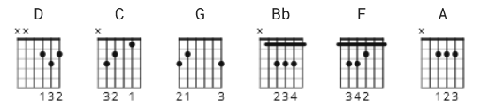

[Intro]

D D C C G G G G 4x

[Verse]

D C G
I saw a werewolf with a Chinese menu in his hand
D C G
Walking through the streets of Soho in the rain
D C G
He was looking for the place called Lee Ho Fook's
D C G
Gonna get a big dish of beef chow mein

[Chorus]

D C G
Ah-ooooo, werewolves of London
D C G
Ah-ooooo
D C G
Ah-ooooo, werewolves of London
D C G
Ah-ooooo

[Verse]

D C G
If you hear him howling around your kitchen door
D C G
You better not let him in
D C G
Little old lady got mutilated late last night
D C G
Werewolves of London again
[Chorus]

D C G
Ah-ooooo, werewolves of London
D C G
Ah-ooooo
D C G
Ah-ooooo, werewolves of London
D C G
Ah-ooooo

[Bridge]

D D C C G G G G 4x

[Verse]

D C G
He's the hairy-handed gent who ran amok in Kent
D C G
Lately he's been overheard in Mayfair
D C G
You better stay away from him, he'll rip your lungs out, Jim
D C G
Ha, I'd like to meet his tailor

[Chorus]

D C G
Ah-ooooo, werewolves of London
D C G
Ah-ooooo
D C G
Ah-ooooo, werewolves of London
D C G
Ah-ooooo

[Verse]

D C G
Well, I saw Lon Chaney walking with the Queen
D C G
Doing the werewolves of London
D C G
I saw Lon Chaney Jr. walking with the Queen
D C G
Doing the werewolves of London
D C G
I saw a werewolf drinking a piña colada at Trader Vic's
D C G
His hair was perfect

[Chorus]

D C G
Ah-ooooo
D C G
Werewolves of London, draw blood

D C G
Ah-ooooo
D C G
Werewolves of London

[Outro]

D C G

--------------------------
* Alternates:

Capo II

D = C
C = Bb
G = F

Capo V

D = A
C = G
G = D

