We Wish You A Merry Christmas (V2) English Traditional

abbreviated chart, full song key B

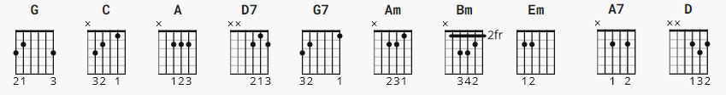
strumming: the song is 3/4 time, so count 1 2 3 1 2 3 . . .
no capo

[Intro]

G B Em C Am D7 G
We wish you a Merry Christmas and a Hap-py New Year!
---
[verse]

G C
We wish you a Merry Christmas
A D
We wish you a Merry Christmas
Bm Em
We wish you a Merry Christmas
Am D7 G
And a Happy New Year.
---
[verse]

G C
Please bring us a figgy pudding,
A D7
Please bring us a figgy pudding
Bm Em
Just bring us a figgy pudding
C Am D7 G
And a cup of good cheer!
---
[chorus]

G D
Glad tidings to you
A7 D
Wher-ever you are
G
Glad tidings for Christmas
C D7 G
And a Hap-py New Year!

[play verse - We Wish you a Merry Christmas ]

[play verse - Please bring us some figgy pudding ]

[play Chorus - Glad Tidings we bring ]

[Outro- repeat Intro ] END

