Whiskey River key G Willie Nelson

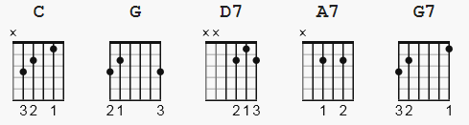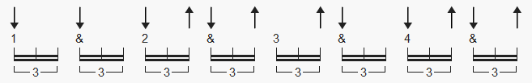
77 bpm 1 2 3 a4 a a6 7 a8 a

alternate 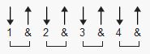

[Chorus]
C
Whiskey River take my mind
G
Don't let her memory torture me
D7
Whiskey River don't run dry
G
You're all I've got take care of me
G C
Whiskey River take my mind
G
Don't let her memory torture me
D7
Whiskey River don't run dry
G
You're all I've got take care of me

[Verse 1]
G C
I'm drowning in a whiskey river
G ( lyrics very fast, G=2 counts )
Bathing my mem'ried mind
A7 D7 ( each A7, D7 2 counts )
In the wetness of its soul
G
Feeling the amber current
G7 C
Flowing from my mind
D7 G
And leaving a heart you left so cold

[Chorus]
C
Whiskey River take my mind
G
Don't let her memory torture me
D7
Whiskey River don't run dry
G
You're all I've got take care of me

[Instrumental]
[ C (4) G (4) D7 (4) G (4) ] x3 (4)=4 bars ea.

[Verse 2]
G C
I'm drowning in a whiskey river
G
Bathing my mem'ried mind
A7 D7
In the wetness of its soul
G
Feeling the amber current
G7 C
Flowing from my mind
D7 G
And leaving a heart you left so cold

[Chorus]
C
Whiskey River take my mind
G
Don't let her memory torture me
D7
Whiskey River don't run dry
G
You're all I've got, take care of me

[Outro]

C G D7 G
C G D7 G
Whiskey River take my mind

-----------
https://www.youtube.com/watch?v=MSYEvTni79M

https://www.youtube.com/watch?v=lPkEmBCZTlA

