Whos Gonna Ride Your Wild Horses U2 key G

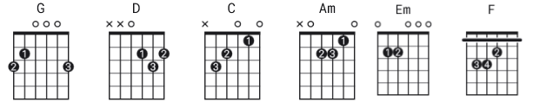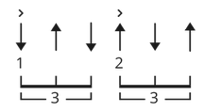

G 32003x strum D DU UDU evenly throughout
each end of line is 8 counts
[Intro] except the sha la la lines
???

[Verse 1]
G D C
You're dangerous, 'cos you're honest
G D C
You're dangerous, you don't know what you want
G D C
Well, you left my heart empty as a vacant lot
G D C
For any spirit to haunt

D C D C
Hey hey, sha la la, Hey hey

[Verse 2]
G D C
You're an accident waiting to happen
G D C
You're a piece of glass left there on the beach
G D C
Well, you tell me things I know you're not supposed to
G D C
You leave me just out of reach

D C
Hey hey, sha la la
D C
Hey hey, sha la la

[Chorus]
G D C
Who's gonna ride your wild horses?
G D C
Who's gonna drown in your blue sea?
G D C
Who's gonna ride your wild horses?
G D C
Who's gonna fall at the foot of thee?
[Verse 3]
G D C
Well, you stole it, 'cos I needed the cash
G D C
And you killed it, 'cos I wanted revenge
G D C
Well, you lied to me, 'cos I asked you to
G D C
Baby, can we still be friends?

D C
Hey hey, sha la la
D C
Hey hey, sha la la

[Chorus]
G D C
Who's gonna ride your wild horses?
G D C
Who's gonna drown in your blue sea?
G D C
Who's gonna ride your wild horses?
G D C
Who's gonna fall at the foot of thee?

[Bridge]
Am Em
Oh, the deeper I spin
G D
Oh, the hunter will sin for your ivory skin
Am
Took a drive in the dirty rain
Em
To a place where the wind calls your name
G D
Under the tree, the river laughing at you and me
Am Em F D
Hallelujah, heaven's white rose, the doors you open I just can't
close
[verse]

G D
Don't turn around
C
Don't turn around again
G D C
Don't turn around, your gypsy heart
G D
Don't turn around
C
Don't turn around again

G D C
Don't turn around, and don't look back
D C
Come on now love
D C
Don't you look back!

[Outro]
G D C
Who's gonna ride your wild horses?
G D C
Who's gonna drown in your blue sea?
G D C
Who's gonna taste your salt water kisses?
G D C
Who's gonna take the place of me?
G D C
Who's gonna ride your wild horses?
G D C
Who's gonna tame the heart of thee?

(fade out)

see next sheet for better positioning of chords on non-bar
boundaries
