Winter Wonderland folk key C (?)

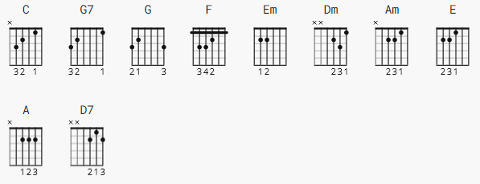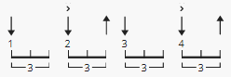

111 bpm
[Intro]
not at present

[Verse 1]

C
Sleigh bells ring are you listening?
G7
In the lane snow is glistening
G F
A beautiful sight
Em Dm
We're happy tonight
Am G7 C
Walking in a winter wonderland

[Verse 2]

C
Gone away is the bluebird
G7
Here to stay is a new bird
G F
He sings a love song
Em Dm
As we go along
Am G7 C
Walking in a winter wonderland

[Chorus]

E A E
In the meadow we can build a snowman
E A E
Then pretend that he is Parson Brown
G C
He'll say: "Are you married"?
G
We'll say: "No man"!
G D7
But you can do the job
G G7
When you're in town

[Verse 3]

C
Later on we'll conspire
G7
As we dream by the fire
G F
To face unafraid
Em Dm
The plans that we've made
Am G7 C
Walking in a winter wonderland

[Chorus]

E A E
In the meadow we can build a snowman
E A E
And pretend that he's a circus clown
G C G
We'll have lots of fun with mister snowman
G D7 G G7
Until the other kiddies knock him down

[Verse 4]

C
When it snows ain't it thrilling
G7
Though your nose gets a chilling
G F Em Dm
We'll frolic and play the Eskimo way
Am G7 C
Walking in a winter wonderland
Am G7 C
Walking in a winter wonderland
Am G7 C
Walking in a winter wonderland

[Outro]
none

