Witchy Woman Eagles

NOTE: This is the setup sheet; the actual chords follow
on sheet 2. There are 2 versions of F and Gm.

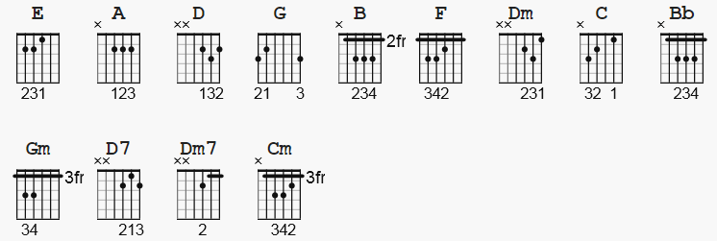

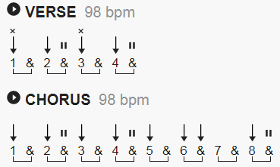

4/4 TIME @ 99 BPM (4 Min. 8 Sec.) in 'Gm' (or 'Bb').

Chords Used:
-----------
GUITAR KEYBOARD
E A D G B e Bass| Chord
------------------ ---------------
Gm* - x 10 12 12 11 10 G Bb-D-G
F - x 8 10 10 10 8 F A-C-F
Dm - x 5 7 7 6 5 D A-D-F
C - x 3 5 5 5 3 C G-C-E
Bb - x 1 3 3 3 1 Bb F-Bb-D
Gm - 3 5 5 3 3 3 G G-Bb-D
D7 - x 5 7 5 7 5 D A-C-D-F#
D - x 5 7 7 7 5 D A-D-F#
F* - 1 3 3 2 1 1 F F-A-C
Dm7 - x 5 7 5 6 5 D A-C-D-F
Cm - x 3 5 5 4 3 C G-C-Eb
Witchy Woman Eagles

INTRO: [12 bars] For 'Gm*' chord, 'Hammer On' D-G-B strings (12-12-11)
----- from initial x-10-10-10-10-10 (Dm7/G) strum.

1234 1 +234 1 +234 1 +2 +34… 1 + 2+34
|Gm* |F Dm |F Dm |C Bb Gm |Gm* |F Dm |F Dm |C Bb C |Gm |Gm |Gm |Gm|

VERSE #1: [8 M]
--------

|Gm |D7 |
Ra-… ven hair… and ru-… by lips,…

|D7 |C Bb Gm |
sparks… fly… from… her fin---ger tips . . .

|Gm |D7 |
Ech-oed… voic-es… in… the night,… She's a

|D7 |C Bb Gm |
rest-… less spir-… it on an end-less… flight…

CHORUS #1: [12 M]
---------

|Gm |D7 |D7 |C Bb Gm |
Woo-… hoo,… witch-y wo- man,… see how… high… she flies…

|Gm |D7 |D7 |C Bb Gm |
Woo-… hoo,… witch-y wo- man, she got the moon in her eyes…

1 2 3 4 1 +234 1 + 2 +3+ 4 + 1+ 2 +3+4+
|Bb Gm |F D |F D C D C Bb C| Bb F* Gm |
She

VERSE #2: [8 M]
--------

|Gm |D7 |
held… me spell-… bound… in… the night,

|D7 |C Bb Gm |
danc-… in' sha-… dows… and fire-… light…

|Gm |D7 |
Cra-… zy laugh-… ter in an-oth-er… room,… and she

|D7 |C Bb Gm |
drove her-self to mad-ness, with a sil-… ver spoon…

CHORUS #2: [16 M]
---------

|Gm |D7 |D7 |C Bb Gm |
Woo-… hoo,… witch-y wo- man,… see how… high… she flies…

|Gm |D7 |D7 |C |
Woo-… hoo,… witch-y wo- man, she got the moon in her eyes…

1 + 2 +3 4 1 2 3 4 1 +2 3 4 1 +2+3+4+ 1 + 2+ 3 4
|… Bb F* Gm |Bb Gm |F D |F D C D F|D C Bb Gm |
…

1 2 3 4 1 +2 3 4 1 +2+3+4+ 1 + 2+ 3 4
|Bb Gm |F D |F D C D F|D C Bb Gm |

INTERLUDE #1: [8 M]
------------

|Gm |Gm |C Bb |Gm |Gm |Gm |Bb C |Gm |

REFRAIN: [8 M]
-------
1 +2 +3 4
|Gm |Dm7 |D7 |C Bb Gm |
Ah,… ah…
[Ah,… ah… ]

|Gm |Dm7 |D7 |C Bb Gm |
Ah,… ah…
[Ah,… ah… ]

INTERLUDE #2: [8 M]
------------

1 2 3 4 1 +2 3 4 1 +2 3 4 1 +2 +3 4
|Bb Gm |F D |F D |C Bb Gm |

1 + 2+3+ 4 +
|Bb Gm |F D |F D |C Bb C |
Well I know…

VERSE #3: [8 M]
--------

|Gm |Gm |
… you wan-na love her,… but let me tell you, bro-ther, she's been

|Cm Bb Gm |
sleep-in' in the dev-… il's bed…

|… |Gm |
And there's some ru-mors go-in' 'round,…

|Gm |Bb C |
some-one's un-der-ground… She can rock you in the night un-til your

|Gm |
skin turns… red…

CHORUS #3: [14 M] 'CODA' -
---------
1 +2 +3 4
|Gm |D7 |D7 |C Bb Gm |
Woo-… hoo,… witch-y wo- man,… see how… high… she flies…

|Gm |D7 |D7 |C Bb Gm |
Woo-… hoo,… witch-y wo- man, she got the moon in her eyes…

1 + 2 +3+ 4 + 1 + 2 + 3 4 1 + 2 +3+ 4 + 1 2 3 4
|F D C D C Bb C|… Bb F* Gm |F D C D C Bb C|… Bb F*|Gm |Gm |

